AWEX Bucharest – The Impact of Covid-19 on the Romanian Economy

Country Context: Romania  Population, million  GDP, current US$ billion  GDP per capita, current US$  Life Expectancy at Birth, years | 2019  19.3  249.2  12,881  75.3

Overview
In 2019 the Romanian economy continued growing at a robust rate of 4.1%. Growth was driven by a strong expansion of private consumption on the back of pro-cyclical fiscal policy, including public salary and pension hikes. That was before the coronavirus pandemic left Romania, and the rest of the world, grappling with uncertainty.

Like every other country in the world, Romania is facing one of the biggest crises of the last few decades, lacking the resources it needs to respond to the health emergency. But the toll the coronavirus will take on the country is difficult to predict, as economic forecasting is currently subject to substantial uncertainties ranging from the duration and severity of the SARS-Cov-2 outbreak to the post-corona-crisis developments.

Romania had already entered 2020 with certain challenges to its economy, such as, with great twin deficits, high financing needs, crippled infrastructure, a workforce crisis, and political turmoil. But the global downturn triggered by the new coronavirus adds a lot of pain to this already tough state of affairs. And the first forecasts indicate a very high impact from the coronavirus crisis.

In 2020, the EBRD expects Romania’s GDP to fall by 4%, assuming most of the containment measures are removed by the end of the second quarter. The Romanian economy will be affected by lower consumption, postponed investments and a drop in demand for its exports.

“While we still don’t have enough data to assess the economic impact, the first estimates we’re getting from confidence surveys and economic players converge towards the same conclusion: in the course of only a few weeks we will experience a contraction that normally would have taken several bad years to materialize. Considering that a -4 percent contraction in Germany has become the most optimistic scenario, and that France is losing roughly the equivalent of 3 percentage points of GDP with every month of lockdown, Romania’s position is unlikely to look any better,” explains Valentin Tataru, economist at ING Bank Romania. “The magnitude and rapidity of current developments is unprecedented. (…) We believe that GDP contraction will begin in 1Q20 and estimate a -1.3 percent drop vs 4Q19 (+1.7 percent vs 1Q19), despite the probably strong first two months. The bulk of the current anti-pandemic measures will be visible in 2Q20, where we see a -19.7 percent contraction vs 1Q20 (-19.1 percent vs 2Q19), with the main drags coming from industry and trade,” Valentin Tataru further estimates.

In the pages below, we will present a timeline of the measures taken by the Romanian authorities and we will try to assess the effects on certain sectors of the Romanian economy.

List of Economic Measures
1. 2020-03-16: Declaration of the state of emergency
2. 2020-03-21: Deferral of payment of certain taxes and utilities, introduction of technical unemployment, state guarantee of 80% for certain corporate loans
3. 2020-03-29: Freezing the price of utilities and fuel
4. 2020-03-30: 9-month moratorium on loan repayment for companies and individuals
5. 2020-04-16: The government launches the IMM-Invest program as a stimulus for SME's
6. 2020-04-26: Differentiated tax reductions for companies that pay their due taxes ahead of deadline

List of social measures
1. 2020-03-16: Declaration of the state of emergency
2. 2020-03-17: Closure of restaurants, pubs, theaters, churches, sports bars, ban of outdoor events and events for more than 100 people
3. 2020-03-19: Closure of dental offices
4. 2020-03-20: Strict control of those in home quarantine
5. 2020-03-24: Curfew, 1.5 meters distance in institutions, suspension of additional flights
6. 2020-03-29: Higher penalties for violating the curfew, more than 3 people are not allowed to walk in groups
7. 2020-03-31: Leaving home quarantine is a criminal offense
8. 2020-04-16: Extension of the state of emergency till 15th may
9. 2020-04-27: Kindergartens, schools and universities will remain closed until autumn
10. 2020-04-27: The first easing: persons above 65 may leave their homes in two intervals per day
11. 2020-05-06: The Constitutional Court of Romania rules that the fines for breaching the state of emergency are unconstitutional
12. 2020-05-15: The countrywide state of emergency is relaxed into a state of alert

List of financial measures
1. 2020-03-18: NBR is working alongside the government, public authorities and the banking system to mitigate the negative effects of the COVID-19 pandemic
2. 2020-03-20: NBR decides (1) to cut the monetary policy rate from 2.5 percent to 2.0 percent; (2) to narrow the interest rate corridor (3); to provide liquidity to credit institutions and (4) to purchase government securities on the secondary market
3. 2020-03-24: NBR announces measures to increase the flexibility of the legislative framework so that banks and NBFIs could help individuals and companies with outstanding loans
4. 2020-03-25: The Financial Supervisory Authority lifts the 70% upper limit on the fixed-income holdings of private pension funds.
5. 2020-03-31: Press statement from the NBR Governor: The peak of tensions generated by the COVID-19 crisis in the monetary, banking and financial field has been overcome

Policy response
Once the outbreak is contained, a swift recovery, while not guaranteed, is possible. Nevertheless, early data show that the unemployment rate has ticked up in March to 4.6% from 3.9% in February, with more upside risks in the coming months. The persistence of more long-term negative effects, especially in the labor market, as well as the speed of recovery, will depend significantly on the government’s ability to absorb these shocks. Engagement with EU institutions and international financial institutions will help the authorities to access extra funding and technical support.

The crisis response measures aim to support the economy’s liquidity and preserve jobs. The announced fiscal package of about 3% of GDP includes additional funds for the healthcare system, partial coverage of the wages of parents staying home during school closures and for furloughed workers, and guarantees for supporting lending to small and medium-sized enterprises. Other measures include a deferral of loan payments for firms and citizens of up to nine months, faster reimbursement of VAT, suspending foreclosures on overdue debtors, and postponement of property tax by three months. The support is there. However, when it is quantified, Romania seems to be at a lower end of the range among its regional EU peers, with Hungary, Poland, and Slovenia committing more than 10% of GDP in the form of crisis response packages.

Further support may be limited in the context of the government's fiscal position. Even before the onset of the coronavirus crisis, Romania would have been the only EU country with a budget deficit of over 3% of GDP for 2020, following the estimated deficit of 4.6% of GDP in 2019. While the EU has relaxed budgetary rules (allowing countries to adequately respond to the crisis), it is still more difficult for Romania to support the economy than for the countries that entered the crisis with a more solid fiscal standing. With the estimated fiscal stimulus amounting to around 3% of GDP, the fiscal deficit in 2020 could balloon to almost 9% of GDP, as per the recent forecast from the International Monetary Fund (IMF), compared to a deficit of 6.7% of GDP, as envisioned by the revised budget. In this regard, Romania’s low resilience to external funding shock is a major risk – in this sense, the Fitch and Moody’s outlook rating downgrades to negative are a sign.

Romania still has a relatively moderate level of public debt, which is a mitigating factor. The amount of existing debt plays a crucial role in how much a country can still borrow and at what cost. Romania’s public debt at the end of 2019 was about 35% of GDP, much lower compared to a number of regional EU peers, including Croatia, Slovenia and Hungary, all at about 70% of GDP, and Poland and the Slovak Republic at about 50%.

The National Bank of Romania (NBR), which started buying public debt, is playing a key role in stabilizing the immediate cost of the crisis. The NBR has reacted promptly to loosen monetary policy. It reduced the monetary policy rate by 0.50 percentage points to 2.0%; narrowed the related interest rates corridor to ±0.5 percentage points from ±1.0 percentage points, lowering further the lending facility rate to 2.5% (from 3.5%); and provided liquidity to credit institutions via repo transactions (repurchase of the government securities). The NBR also intervened in the foreign exchange markets to stabilize the RON-EUR rate, given the high depreciation pressures.

Impact by Sectors
"The first sectors that feel the impact of the COVID-19 pandemic are those that depend on the people's mobility: transport, hospitality, tourism. But the negative effects will gradually be transmitted to other fields of activity because all industries are interconnected. For this reason, rapid measures are needed for the survival of those seriously affected, as well as a medium-term economic recovery plan. I believe that, in the first phase, the measures to be taken must ensure cash flow continuity for those whose revenues are reduced sharply. I am referring to the payment of the debts that the state has towards companies, for example, the immediate VAT reimbursement, the amounts for medical leave, as well as the postponement of the payment of taxes and contributions. In the second phase, after a more thorough impact assessment, a plan of measures should be devised to support the private environment in order to maintain jobs and, implicitly, the incomes of the population and companies”, said Daniel Anghel, Partner, TLS Leader of PwC Romania.
Tourism and Hospitality
Two of the sectors most affected by the crisis caused by COVID19 are tourism and hospitality. Many businesses already have cash flow problems, while the risk of layoffs, insolvencies and bankruptcies increases significantly is creating cascading effects that affect us all.

The tourism industry is, by definition, one of the most vulnerable industries when it comes to threats related to an economic, military or medical crisis. COVID19 has produced dramatic effects for the Romanian tourism and hospitability industry, as nearly 90% of the business suddenly dropped.

Three of the top challenges during this crisis period have been managing clients who were already on vacation or on business trips, managing the cascading cancellations from all types of clients and securing the jobs of employees and collaborators.

The Employers’ Associations in Tourism have asked the government for the following measures to support this sector:
- Technical unemployment pay 75% of income and taxes paid by the state;
- Immediate payment of state debts to companies: VAT to be recovered without prior control, medical leave, urgent payment of outstanding invoices;
- Measures to defer loan installments to banks and / or leasing companies without consequences for companies;
- Government loans granted quickly for liquidity needs, without collaterals, on preferential financial terms and with long-term repayment;
- Providing liquidity for companies by state-guaranteed emergency loans from commercial banks.

Most companies in the business are cautiously optimistic, as the government decided to open the hotels and restaurants (outdoor seating only), as well as the Romanian beaches starting with June 1st and are contemplating opening all restaurants (except for event halls) staring with June 15th. They are also hoping that most people will prefer to vacation in the country, for safety reasons and will avoid travelling abroad.

Textile Industry
The textile industry in Romania has been affected since the start of the pandemic in China, with delays in providing raw materials, as China was the main supplier for accessories and material. Once the factories in China were closed, many brands/retailers moved the production to Turkey.

The Covid-19 pandemic has had a major impact on the textile industry. Currently there is stagnation in production with about a 30% reduction in the export capacity of factories. The forecast analyses show a decrease of orders by over 40% compared to the previous year. At the same time, this accounts for a decrease in production capacity through layoffs at approximately 30% of the factories.

According to the Federation of Employers of Textiles, Clothing and Leather (FEPAIUS), the negative impact of the Covid-19 pandemic is reflected on several levels. Thus, there are difficulties in the supply of raw materials and accessories both as a result of the decrease in transportation and as a result of the suspension of activities of many Italian producers. Romania’s exports to Italy amount to 4.7 billion lei, while imports account for 6.3 billion lei.

At the same time, there is a risk of cancelling customer orders due to delayed delivery times. Delays are also seen in receipts, from 30 days to 45-50 or more. But the worst effect of this epidemic on the textile industry is the impact on the Romanian workforce.

Factories have not been specifically asked to stop production, but they need to monitor and follow advice and guidance from relevant authorities such as the World Health Organisation (‘WHO’), the Ministry of Health (MH guidance), the Ministry of Foreign Affairs (MAE guidance), the National Institute for Public Health (NIPH guidance) and the government (government guidance). The factories are able to keep up with work as long as they have still valid orders and no workers have been infected. Obstacles to the free movement of goods is affecting supply chains, but Romania is working on transport corridors and has largely abolished quarantine regulations for truck drivers. However, truck drivers are obliged to carry protective equipment with them.

Even after 2 months of the pandemic, the factories are struggling to keep up with the difficult times, whether that’s the uncertain status of orders, lack of raw materials or higher standards for the safety of the workers. Under the pandemic circumstances, factories are struggling to keep business going and this will be affected by the duration of the situation. Factories are faced with financial losses caused by fixed costs like payment of rent, utilities, state taxes, salaries, VAT, etc.

Within these divergent situations, there is a notable initiative: a group of factories joined up to create a national hub for medical textiles. The first step was taken by the national producer of Voluminous waddings, the factory ‘Minet SA’ from Râmnicu Vâlcea. There are 52 Romanian local producers, with a total of 10,000 workers, that have joined the initiative. The initiative is working jointly with the National Agency for Military Research for Engineering and technology to approve a material (development and production) with protective role, with proper use for suits and masks.

An Outlook to Recovery

The current crisis has shed light on the vulnerabilities of the Romanian economy, ranging from an underdeveloped health system to the high risks associated with a lack of budgetary discipline. As the outbreak becomes contained, the country will need a macroeconomic stabilization strategy and a habit for prudent fiscal policies. As the saying goes, never waste a good crisis – the recovery period will present new opportunities that Romania must take advantage of.

Over-dependence on global value chains is likely to be reconsidered and closer markets will come to light. Firms, especially multinationals, will likely reorient their supply chains from cost-effectiveness towards optimal resilience. In this sense, given its size and cost competitiveness, there is an opportunity for Romania to attract investments that will relocate from Asia, and particularly China, back to Europe. However, the competition for foreign direct investment in the region will likely be high, and solving bottlenecks, such as infrastructure, will be key.

This crisis can and should act as an accelerator to boost digitalization. Despite steady progress, the use of digital solutions in the country remains relatively low. Romanians are ranked second-last at online shopping in the EU. E-signatures, e-commerce, e-banking, and e-governance are becoming business norms. Online education is also likely to become more widespread and can provide greater opportunities for children in remote and rural areas. Appropriate digital infrastructure and regulatory frameworks can give a much-needed boost to the country’s rural and regional development.

The recovery strategy should focus on old bottlenecks. Besides responding to the problems created by the pandemic, the government should speed up overdue reforms. Policy goals include improving governance by strengthening the civil service and public administration; further supporting the capital markets; developing infrastructure and improving public services; and improving the efficiency of state-owned enterprises through better corporate governance, among other things.

Lastly, the lockdown caused by the pandemic should serve as an opportunity to reassess the current model of economic development and rethink the way forward. On the path to recovery and further convergence to EU standards of living, Romanians must agree on a set of national priorities, to be implemented by all political parties. With short-termism becoming less prevalent, long-term projects must start materializing.

Sources:

https://www.worldbank.org/en/country/romania/overview#3

https://econ.ubbcluj.ro/coronavirus/

https://insse.ro/cms/en/publicatii-statistice-in-format-electronic?field_categorie_publicatie_value_i18n%5B0%5D=10&created=1&field_cuvinte_cheie_value=&items_per_page=10&page=3

https://www.romania-insider.com/ebrd-comment-romania-cornavirus-may-2020

https://www.statista.com/statistics/1106097/covid-19-impact-inflation-rate-romania/

https://www.fairwear.org/covid-19-dossier/covid-19-guidance-for-production-countries/covid-19-impact-and-responses-romania/

Macroeconomic indicators
Presentation of key macroeconomic indicators

Economic Heatmap
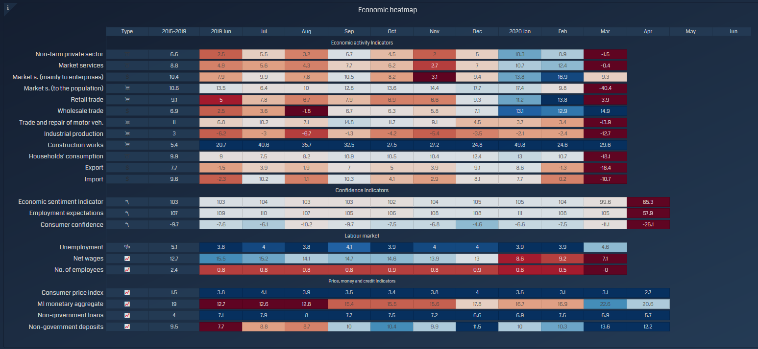
Source: Babes-Bolyai University, Faculty of Economics and Business Administration
Annual GDP growth vs. market and model (DFM) estimates with uncertainty intervals

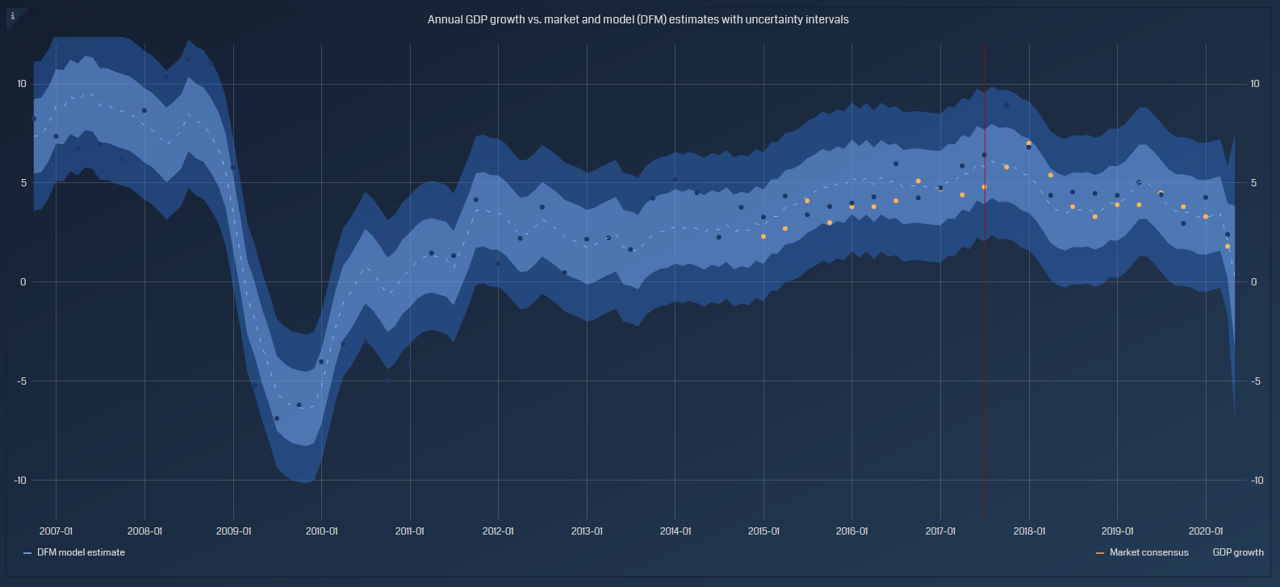
Source: Babes-Bolyai University, Faculty of Economics and Business Administration

Most affected industries based on their size and change in GDP

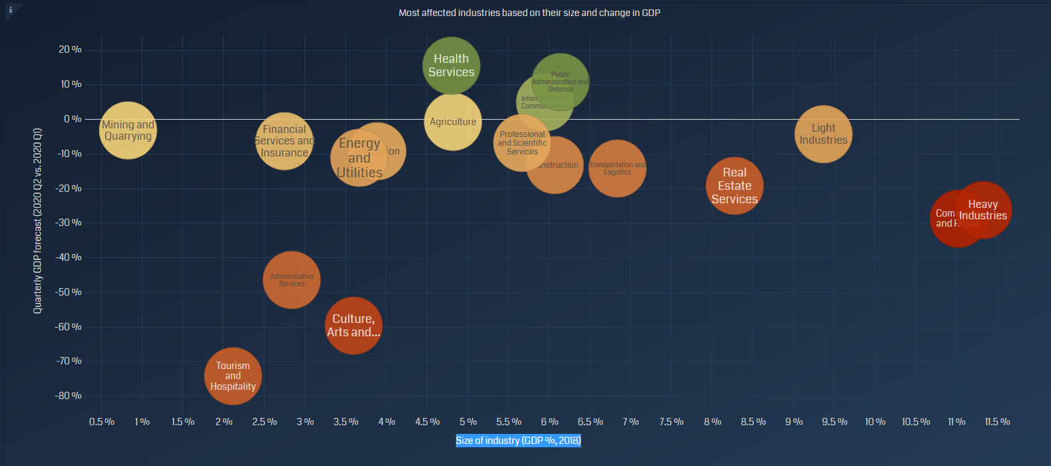
Source: Babes-Bolyai University, Faculty of Economics and Business Administration
County-level effects
Expected impact of the coronavirus pandemic on Romanian counties
Quarterly GDP forecast (2020 Q2 vs. 2020 Q1)
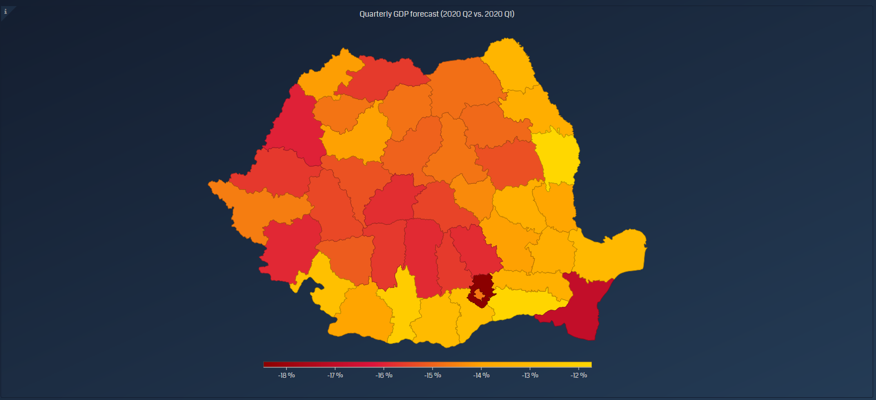
Source: Babes-Bolyai University, Faculty of Economics and Business Administration
