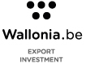

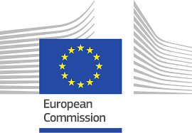

CONFIDENTIAL

EBRD - London

Thursday 22nd and Friday 23rd March 2018

Application for B2B meetings with EBRD

Please sent it back to h.siemes@awex.be at the latest by Friday 2nd February 2018

A. INFORMATION THAT WILL SERVE FOR THE EBRD PROSPECTS/COMPANIES
- Company data
Company name:

Company address:
Street:
Postcode:
City:

Tel:
Mobile:
Website:
E-mail:

Year of establishment:
Total number of staff members:
Turnover in 2017:
Export figures in 2017:

- Full name, job title, telephone number and personal e-mail adress of the company representative(s), participating the trade mission
Participant 1:
Function:
Direct tel nr:
Direct E-mail:
Participant 2:
Function:
Direct tel nr:
Direct E-mail:
- Survey of the activities and strenghts of your company/organization. Also add some nice references of your company abroad

- Describe the products, technologies or services you want to present to the EBRD-sector specialists (23rd March) and to companies (attending the networking reception 22nd March).
In order to find the most suitable contacts, your description must be as accurate as possible. Please clarify the technical and commercial aspects, but also the area of application and the innovative character of your product if this can be of any relevance.
EBRD-(sector) specialists:

UK based companies (participating to the networking event):

One phrase description:

Customs code(s) if applicable:

- If suitable, please fill in the data of contact person(s) within the EBRD.

