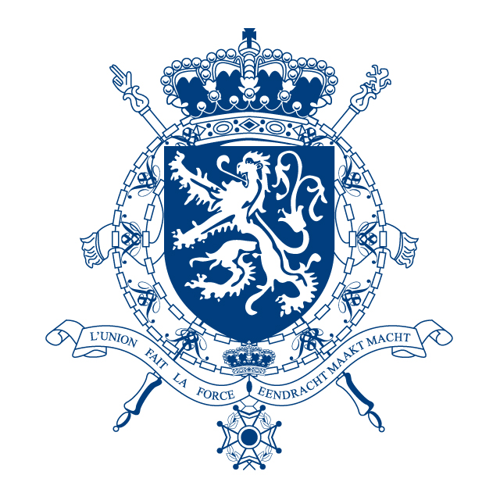 | 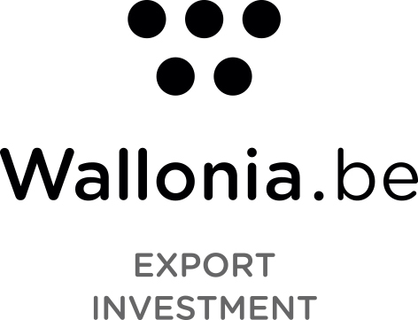

AWEX SOFIA – THE WATER SECTOR IN BULGARIA
September 2015

- General overview of Bulgaria

Bulgaria is a country located in South East Europe with a territory of 110.9 thousand sq. km. As an EU member state since 1 January 2007, Bulgaria is obliged to fulfill its Accession Treaty commitments, of which harmonization of Bulgarian legislation with the European law and other international agreements.

Bulgaria has 7.2 million inhabitants with the lowest average gross wage in the EU 28 (about 5.399 EUR annual gross). In 2014, the Bulgarian economy grew by 1,7% according to IMF. The expectations for 2015 and 2016 are respectively 1,2% and 1,5%. The unemployment rate is around 11% and according to the forecasts there will be a decrease in the coming years. The administration, transport, IT, & trade sector accounts for around two thirds of economic activity (63%), industry 30% and agriculture 7%.

Bulgaria will beneficiate from EU funding for the period 2014-2020, namely in the environment sector. Under the EU fund “Environment”, the water sector will receive most of the money - about 70 % of the total budget will be invested in the sector in order to reach conformity with the EU requirements. So we can expect many projects in the water sector in the coming years.

OPERATIONAL PROGRAM ENVIRONMENT 2014-2020: FINANCIAL ALLOCATION

OP Environment 2014-2020 for Bulgaria : 1 504 824 141 EUR

Priority axis | Amount (in EUR) | Share (%) of the operational program
Water | 1 016 870 809,00 | 67,57%
Waste | 244 616 731,00 | 16,26%
Natura 2000 & biodiversity | 86 181 500,00 | 5,73%
Prevention & management of risk of floods and landslides | 66 749 074,00 | 4,44%
Improvement of air quality | 50 000 000,00 | 3,32%
Technical assistance | 40 406 027,00 | 2,69%

- Water supply and sanitation sector (WSS) : current situation in Bulgaria and challenges

Bulgaria is one of the richest countries in Europe in mineral waters. More than 200 mineral water sources are identified and studied.

The percentage of the population connected to the public water supply network is high: 99,3%.

The water utilities consist of 51 operators (called “ViK”) disseminated across the regions and owned by the State, municipalities or both. The water network of Sofia is an exception: it is a concession where the French group Veolia is the major shareholder. The financial viability of all these operators is low, namely due to a lack of economy of scale. One of the reforms of the sector is to consolidate all 51 ViK in 28 regional associations (one per region).

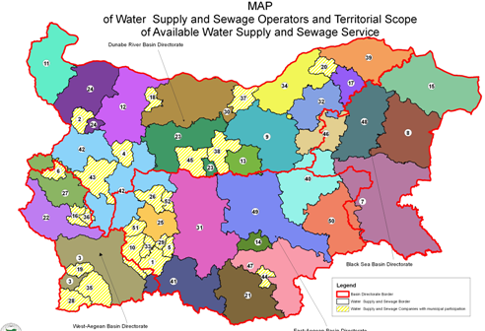

The current status of WSS is not performant and calls for challenges:

Current status | Challenges
Drinking water assets :
- About 75.000 km water supply network (high coverage)  - 60:40 pumped vs. gravity supply  - More than 50 production plants, 6000 reservoirs and 3600 pumping stations | - Average water losses around 60% (very high)  - Insufficient maintenance  - 35% of population considers water quality to be poor ‘very often’ or ‘constantly’ (pressure, odor, taste, turbidity)  - 7% of population reported seasonal scarcity (past 5 years)  - Investments in water supply are far below level to sustain good quality and uninterrupted service in the long run (now 200 mio € annually)  - No cost recovery achieved in many places
Sewerage Assets :
- 10.000 km sewerage network  - Less than 50% population connected to Wastewater Treatment Plants (wwtp) | - Extension of wastewater collection and treatment system is required  - No compliance with the Urban Waste Water Directive : additional WWTP’s for 282 agglomerations are under construction or need to be built to serve 1.8 million population equivalents (PE)  - Few investments in wastewater (now less than 200 million annually)
Dams :
- 53 complex and important dams built with a total volume of 6.7 billion m³  - The number of the irrigation dams is over 2000 | - There are 68 dams that are in dangerous condition  - The water losses in irrigation systems are extremely high – 70-80% of total water supplied

- Improve WSS : EU funds & Bulgarian national strategy

Given the negative diagnosis on the state of the water sector in Bulgaria and because the country needs to meet the EU standards, the Bulgarian government adopted a national strategy in 2014. In this strategy, the necessary costs for the water supply & sanitation sector for the period 2014-2023 amount to 6.25 billion EUR of which 2.55 billion EUR are for water supply (yield, purification, transmission and distribution), 2.25 billion EUR sewerage collectors, and 1.4 billion EUR construction or rehabilitation of wastewater treatment plants.

As mentioned above, the main source of funding in the water sector, are the EU funds Operational Programs "Regions in growth" (OPRD) and "Environment" (OPE) 2014-2020 approved by the European Commission in 2015. Under these funds, about 1 billion EUR will be dedicated to the WSS in Bulgaria.

- 1st focus on feasibility studies

In the short term, the government will focus on the execution of feasibility studies to set up a regional investment planning strategy. The first tenders have been launched in the summer of 2015 for areas where the operators (« ViK ») are already regionally consolidated (as per pre-condition from the European Commission).

In the longer term, we can hope that Bulgaria will execute works to improve the WSS indeed and the expected investments will be in construction of water infrastructure, prevention and management of floods, …

Through funding by the World Bank, 3 new dams for drinking water will be built and Studena dam will be rehabilitated.

- Opportunities for Walloon companies

Due to the fact that the challenges are huge, many opportunities are to be seized by the Walloon companies, in the following areas:
- Consulting and design
- Supply of water equipment and technologies namely for leak monitoring and prevention
- Technical assistance
- Construction works: dams, waste water treatment facilities, water supply and sewerage network, …

- Useful links

Ministry of environment and water: http://www.mrrb.government.bg
Ministry of regional development: www.mrrb.government.bg
Bulgarian Water Assocation: www.bwa-bg.com
Global Water Partnership: http://www.gwp.org/Global/About%20GWP/Publications/Reports/Country%20Consultation%20Reports/Country%20consultations%202014/Bulgaria%20national%20consultation.pdf

named Strategy for Development and Management of Water and Sanitation in the Republic of Bulgaria, approved by Council of Ministers in April 2014 ; http://www.mrrb.government.bg/docs/24e7666f6785ee40bfb094bec3ad5f45.pdf

