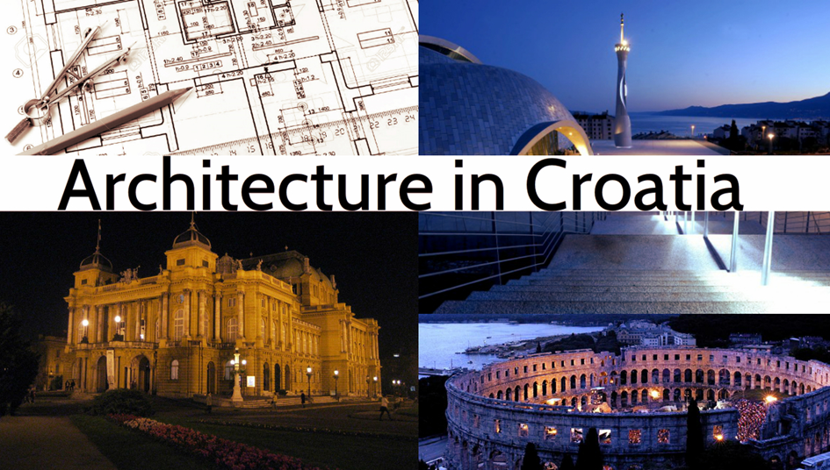

Belgian Trade and Investment Office Zagreb
January 2017
Architecture in Croatia

1.Introduction 3
1.1. General figures about Croatia 3
1.2 Architectural trends in Croatia 3
1.3.History of architecture in Croatia 5
2.Sustainable construction and architecture 6
2.1. Green architecture in Croatia 8
2.2. Potentially leading market in Croatia 10
2.3. Legalization in Croatia 11
2.4. Urbanization 12
3. Planned construction 14
4. Difference between coastal and continental Croatia 14
4.1 Continental Croatia 14
4.2. Coastal Croatia 16
5.Associations of architects in Croatia 17
5.1. Croatian Association of Architects 17
5.2. Croatian Chamber of Architects 17
5.3. Croatia Green Building Council 17
5.4. ORIS 18
6. Education in Croatia 20
6.1. Faculty of Architecture, University of Zagreb 20
6.2. Faculty of Architecture- School of Design, University of Zagreb 20
6.3. Faculty of Civil Engineering, Architecture and Geodesy, University of Split 21
6.4. Faculty of Civil Engineering, University of Osijek, University of Osijek- Architecture and urban planning 22
7.Architects in Croatia 22

1. Introduction

1.1. General figures about Croatia

Information | June 2016
Area (square km) | 56.594
Population (million) | 4 190 669
ISO country code | HR
Main cities | Zagreb (Capital)  Split  Rijeka  Osijek
National currency | Hrvatska kuna (HRK)
Exchange rate | 1€= 7,51
GDP (million EUR, current prices) | 43.870
GDP per capita (in EUR) | 10.435
Unemployment rate | 14%
Average CPI year-on-year inflation rate | -1,5%
VAT | 25%
SOURCE: http://www.hnb.hr/documents/20182/1176175/h-polugodisnja-informacija-1polugodiste2016.pdf/ec45b0b7-b46d-4cf0-8937-a5bc73068b70

1.2 Architectural trends in Croatia

It is highly delicate to discuss trends in architecture. To define a style of a construction is not at all as easy as to choose a new dress or buy a new car. Architectural work is far more delicate because it is what remains for many generations. If we look back, we can see how the approach towards architecture has changed thorough history. Architecture itself has changed and evolved through centuries, styles and directions and modified in respect to its field of creation. Therefore, we can say that it does not really matter what style we chose, what trend we decide to follow as long as we create a qualitative architectural piece of work shall remain viable and adjustable over time. If we take two completely opposite opinions, modernist theories, in which the form follows the function, or post-modernist theories, where function follows the form, we basically reach the same conclusion- the form does not exist without the function in as much the function does not exist without the form. What we know for sure is that a piece of architecture is created in regard to context and programme, taking into consideration many other factors as well. The form, volume, space, structure, light and shadowing, materials as pragmatic factors of constructive and technological limitations and costs create the final result of practical and economically work of art.

The best architectural projects in Croatia were up for an award on „Piran Days of Architecture“ in Slovenia.
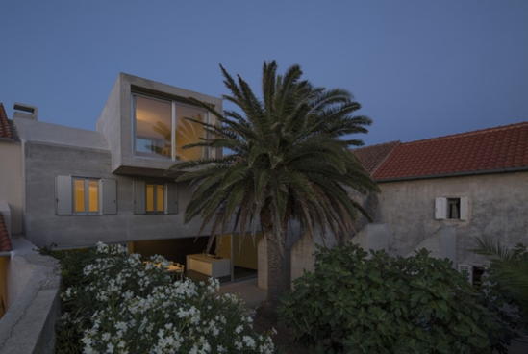

1.)House on Silba, photo by Miljenko Bernfest
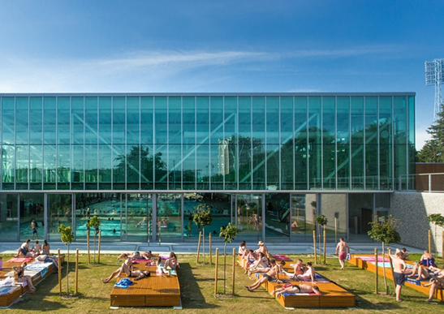
2.) Swimming pool in Zagreb, photo by Marko Mihaljevic

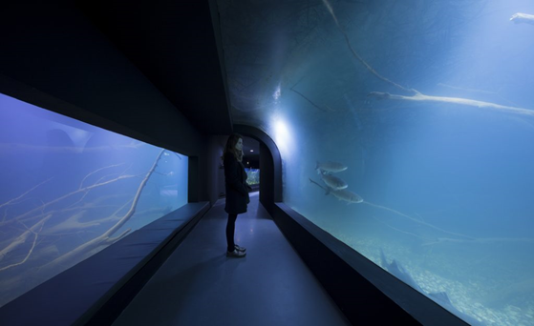
3.) Aquatika in Karlovac, photo by Jure Zivkovic
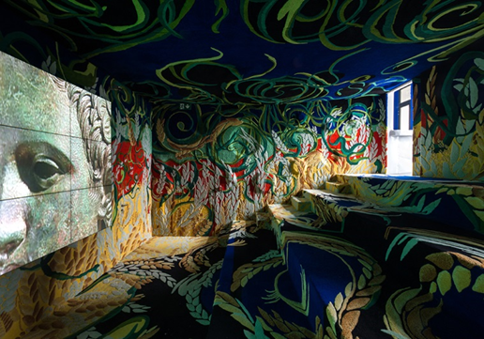
4.) Hotel Amarin in Rovinj, photo by Hotel Amarin
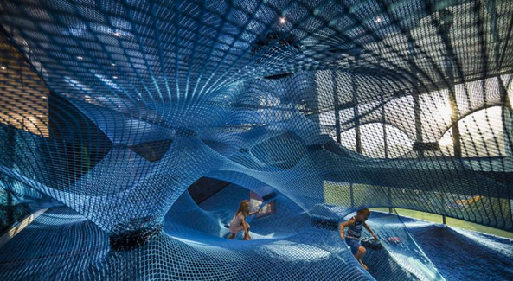
5.) Museum Apoksiomen, photo by Bosnic and Dorotic

1.3. History of architecture in Croatia

Croatia's oldest still standing architecture is from the Roman times. The two best examples from this time are the Pula Arena in Pula and Diocletian's Palace in Split. The palace, however, has mostly been destroyed, although many walls and buildings still remain. Over time, new buildings have been put up in the space, including structures in Romanesque, Renaissance, and Baroque styles. Through the next millennium, most of the architecture introduced in Croatia was church architecture or fortifications, primarily consisting of stone and Romanesque structures. The Euphrasian Basilica in Porec is a great example of early Christian (300's) church architecture as are many of the churches and buildings in Trogir.
The first distinctively Croatian design feature appears frequently on buildings until the 11th century. The interlaced ornamentation is called "pleter" and is still a popular design feature. Most representative examples of inscriptions embellished with the interlace include the Baška tablet and the Branimir Inscription. Other notable examples are located near Knin, in Zdrapanj and Zavić by the Bribir settlement, Rižinice near Solin and in Split and Zadar.
The Roman heritage in Croatia spans six centuries, beginning with constructions in Istria and ending up with 1st-century basilicas in Solin. The aisled basilica of St Stasat Marusinac, with its open nave, is a rare example of a roofless basilica in which open-air funeral rites were performed. The unusual width of the nave recalls the Peristyle of Diocletian's Palace in Split, a World Heritage site and the largest Roman monument in Croatia.
The most impressive Romanesque church in Croatia is the circular Church of St Donat in Zadar which dates from the 9th century.
The earliest Gothic style appeared in Trogir on the renowned Cathedral of St Lovro. In Zagreb, the Cathedral of the Assumption of the Blessed Virgin Mary displays early Gothic influences.
The Romantic Movement in Croatia was a reflection of the bourgeoisie's humble and modest virtues. In architecture, there were simple decorations made of shallow arch-like niches around windows.
The city of Dubrovnik and its beginnings as a sea power date to the 1200’s, when Gothic architecture was common in Croatia. Much of the city's architecture is from this period, although it has been reconstructed. Nevertheless, today many of the buildings have Renaissance or Baroque facades along with a couple of churches in each of these styles.
Dubrovnik remained a power through the next couple of hundred years, so when the next influential movement in Croatia arrived in the Renaissance, Dubrovnik continued building, now in this new style. Venice ruled over much of Croatia's Dalmatian Coast through this period and hence brought this new style to numerous cities and buildings in the region. The most well-known and important of these Renaissance buildings, however, is not in Dubrovnik, but it is St. James Cathedral in Šibenik (1400-1500’s).

2. Sustainable construction and architecture

Sustainable construction means more than building new homes, offices and factories. It involves using sustainable materials, safe construction activities, all in accordance with the new construction technologies. Sustainable construction methods and materials are being used with the construction of new buildings. As a result, noise is reduced, and so is interference and waste in urban areas, energy consumption and thus the impact on the environment (locally and globally).
Sustainable buildings are economically efficient, environmentally friendly and acceptable, and protect natural resources. Such objects are comfortable and healthy for users. When we talk about thermal insulation of buildings, sustainable construction means enabling a comfortable environment with minimal heating and cooling costs for buildings. Reducing the cost of heating and cooling is directly related to energy requirements.
When it comes to defining sustainable construction, “sustainability” is one of the world’s most talked about, but least understood words. Its meaning is often clouded by differing interpretations and by a tendency for the subject to be treated superficially. For most companies, countries and individuals who do take the subject seriously, the concept of sustainability embraces the preservation of the environment as well as critical development-related issues such as the efficient use of resources, continual social progress, stable economic growth, and the eradication of poverty.
Increasing numbers of people are looking to minimize both environmental impact and financial outlay by outfitting their homes with sustainable technology, and the resulting boom in sustainable building is driving new levels of architectural innovation.
This is an example of how sustainable home construction might look like:
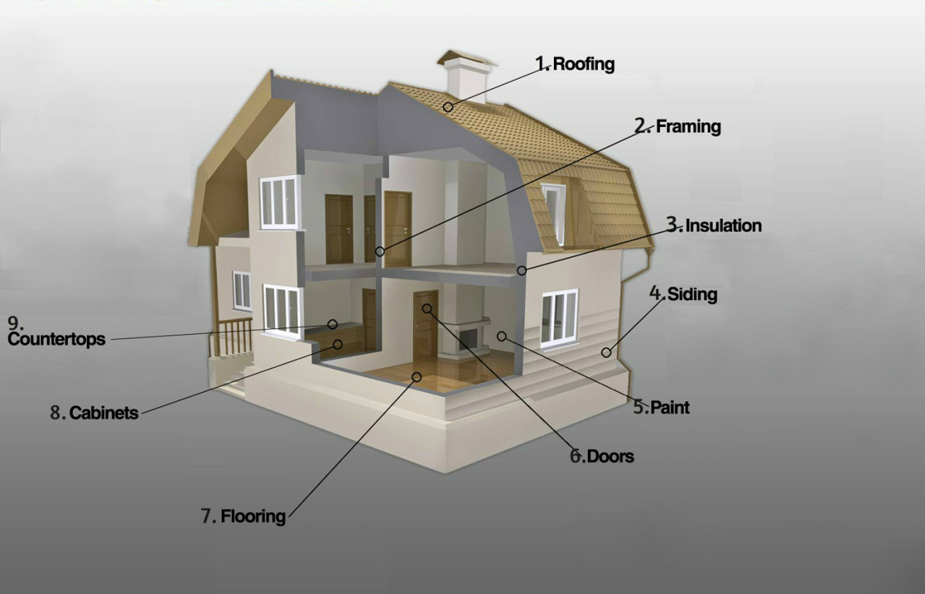
- Roofing: fibre-cement composite roof materials use fibre materials resourcefully. Some use waste paper as well wood fibre. Many have 60 years warranties.
- Framing: engineered structural products are recycled/reconstituted wood materials that employ laminated wood chips or strands and finger jointing (the gluing of larger pieces together). These materials drastically minimize the amount of waste created in processing the raw materials. Waste wood and entire trees, regardless of species, shape, and age, can be used in making these products.
- Insulation: engineered materials refer to the more efficient (less wasteful) cellulose insulation is made from recycled newspaper and treated with fire retardants and insect protection
- Siding: engineered materials refer to the more efficient (less wasteful) process of using wood or other cellulose fibres bonded together to make a material shape. Reconstituted materials are denser and offer increased longevity. Some products have wood fibre mixed with cement to form extremely durable exterior (fibre-cement) materials. Recycled-content materials include substances that are salvaged from the waste stream such as sawdust and paper.
- Paint: low VOC paint uses less of the volatile organic compounds used to make it that contribute to ozone and smog formation and are linked to respiratory illnesses and memory impairment.
- Doors: recycled/reconstituted doors are typically moulded hardboard materials. Domestic hardwood veneers use a stable resource and assist our national economy.
Some hardwood veneers such as luaun are from tropical mahogany trees. Domestic hardwood panel doors use wood types which are a stable resource in our economy. The panel style reduces the need for potentially harmful adhesives. Recycled doors are reused doors salvaged from earlier projects.
- Flooring: re-used wood flooring is often derived from remilled salvage timbers. It can also be salvaged from old flooring. From an environmental standpoint, this approach saves materials from the waste stream and does not impact living trees.
- Cabinets: solid domestic hardwood cabinets use a wood resource (domestic hardwood trees) which has a positive growth/removal rate on a national basis (trees are growing at a faster rate than they are being removed). Any solid wood components of cabinets using MDF or plywood can also be specified to be a domestic hardwood.
- Countertops: recycled glass (rather than marble mined from the earth) can be used, and mixed with cement

Moreover, it is important to mention the tariff system for electricity production from renewable energy and cogeneration. It defines the right of eligible electricity producers to the incentive price of electricity, which market operator is paid for electricity produced and delivered from plants using renewable energy sources and cogeneration plants.

2.1. Green architecture in Croatia

In recent years, sustainability concept has become the common interest of numerous disciplines. The reason for this popularity is to perform the sustainable development. The Concept of Green Architecture, also known as “sustainable architecture” or “green building,” is the theory, science and style of buildings designed and constructed in accordance with environmentally friendly principles. Green architecture strives to minimize the number of resources consumed in the building's construction, use and operation, as well as curtailing the harm done to the environment through the emission, pollution and waste of its components. To design, construct, operate and maintain buildings energy, water and new materials are utilized as well as amounts of waste causing negative effects to health and environment is generated. In order to limit these effects and design environmentally, sound and resource efficient buildings; “green building systems” must be introduced, clarified, understood and practiced.
Buildings are responsible for 40% of energy consumption and 36% of CO2 emissions in the EU. While new buildings generally need less than three to five litres of heating oil per square meter per year, older buildings consume about 25 litres on average. Some buildings even require up to 60 litres.
There are very few objects in Croatia of low or zero energy efficiency. Initially, those kinds of apartments or offices are more expensive but in the long run, the benefits of such facilities may have significant savings. These savings means lower bills and reducing the outflow of money overseas, from which Croatia imports energy products and maintaining them in the domestic economy.
EU key laws in Energy performance of buildings:
The 2010 Energy Performance of Buildings Directive and the 2012 Energy Efficiency Directive are the EU's main legislation when it comes to reducing the energy consumption of buildings.
On the 30 November 2016 the Commission proposed an update to the Energy Performance of Buildings Directive to help promote the use of smart technology in buildings and to streamline the existing rules. The Commission also published a new buildings database – the EU Building Stock Observatory – to track the energy performance of buildings across Europe.
Under the existing Energy Performance of Buildings Directive:
- energy performance certificates are to be included in all advertisements for the sale or rental of buildings.
- EU countries must establish inspection schemes for heating and air conditioning systems or put in place measures with equivalent effect.
- all new buildings must be nearly zero energy buildings by 31 December 2020 (public buildings by 31 December 2018).
- EU countries must set minimum energy performance requirements for new buildings, for the major renovation of buildings and for the replacement or retrofit of building elements (heating and cooling systems, roofs, walls, etc.).
- EU countries have to draw up lists of national financial measures to improve the energy efficiency of buildings.

The offer for apartments is high in Croatia, including Zagreb. While some have either a good location, or good equipment, most of them are non-compliant with the new EU standards in energy efficiency of buildings.
However, in Zagreb (Trešnjevka), the first solar house was made by the company Zeleni Projekt d.o.o./Green Project (http://eng.greenproject.hr/). Low-energy type buildings as this are necessary in the time we live in.
Using solar panels for heating water is important in order to additionally increase the energy efficiency of the facility.

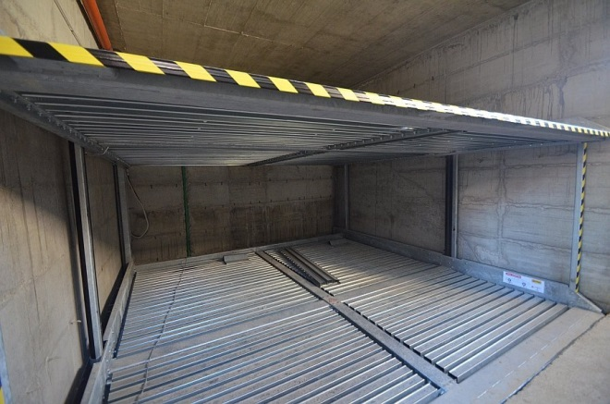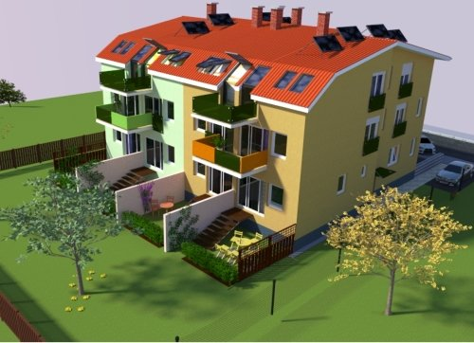
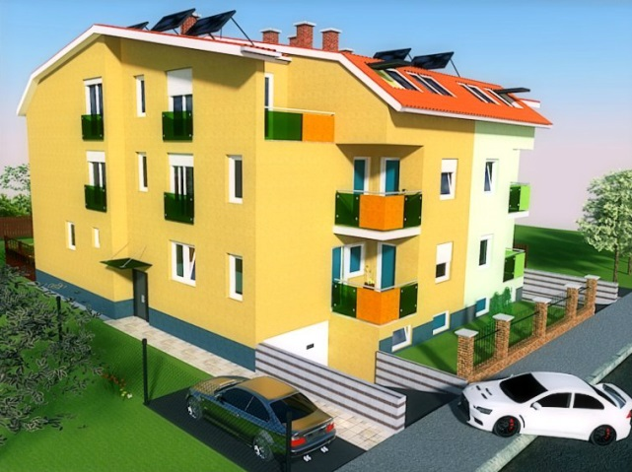 Photos of Trešnjevka building, by Zeleni Project d.o.o.

2.2. Potentially leading market in Croatia

When we talk about the current situation, power generation from fossil fuels is unsustainable in the long term because of the following two reasons:
- A decrease in the quantity of fossil fuels;
- Increasing environmental pollution by the combustion of these fuels.

This creates by-products which heavily pollute the atmosphere and thus cause climate change, which can have disastrous consequences for the world we live in.
An additional problem, common to the European Union and the Republic of Croatia, is increasing uncertainty arising from a lack of energy supply of the world’s own reserves and the need to import oil. Because the world is in that state, it is necessary for Croatia to use a different energy and environmental policy, for the following reasons:
- Orientation towards tourism and production of healthy food. In that sense, reducing local pollution is even greater interest for Croatia than for EU.
- Huge dependence on energy imports that makes Croatia, as a small country, more vulnerable to the vagaries of the EU energy market.

In Croatia, as well as in most other countries, the buildings represent the largest segment of energy consumption, up to 41% of total final energy consumption.

2.3. Legalization in Croatia

The legalization of illegally constructed buildings is a project which aims at solving the decades-old problem of illegal structures and, regarding that, bringing order to the planning state. It is worth noting that the building in this case means a place which serves the accommodation of people, plants, animals and things, houses, garages, farms, hotels and others.
In Croatia, people have filed so far around 800,000 requests for legalization, about 60% of which are solved.
The documentation which should be enclosed for the legalization of illegally built property depends on the category of the entire building.
A request for the legalization of the property must include the following:
- Geodetic report for recording information about the buildings certified by the cadastral office,
- Three copies of the architectural recording - floor plans, sections and elevations - built documentation of illegal building in the scale of 1: 100 or 1:50, which is made by a licensed architect,
- At least four photos in colour, or black and white, the minimum size of 150x100mm, showing the building from the street view and all adjacent sides,
- Opinion of the authorized civil engineer that the building meets the essential requirement of mechanical resistance and stability,
- Certificate of residence,
- Land book excerpt,
- evidence of construction time.
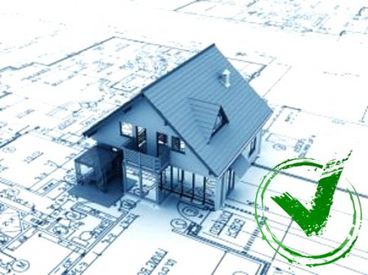

2.4. Urbanization

Urbanization typically occurs when individuals move closer to cities to avoid a long commute to work and to have access to better education, housing and health care. Also, rural and farm life can be more susceptible to drought and hardship. Cities are better known for economic advancements than rural areas, and businesses make the move towards urbanization to remain competitive and to increase growth.
The degree of urbanization is a proportion of population in the cities in a total number of inhabitants of a country. There is a different degree in different parts of Croatia. For example, in continental parts there is a smaller share than in coastal parts. That is because the population from the hinterland and from the island move to cities on the coast and that process is called litoralization (litoralizacija).
In Croatia, the urban system is incorrect, which means that there are mostly small towns and one big/ capital city. Zagreb counts approximately 800,000 while Split counts about 176,000, Zadar about 72,000 and Rijeka about 114,000.
In various cities in Croatia there is an ever mounting amount of urban spread out in shape of commercial and retail growth. Retail chains are in search of the best openings to sell their commodities and services. As this country’s population grows, there is also a rise in housing need. Our suburban communities turned into towns and ultimately cities. There is a raise in required infrastructure, tax base, and growth. Regrettably, it seems that much of this development is leaving behind some of the original town centres and main streets.
Small shopping centres are being replaced with large "box" stores and vast seas of pavement. Buildings that housed banks, gas stations, and the local barber shop are being left behind, surplus shells that are no longer pleasing to their paying guests. Recent years have shown a great demand and interest in the recycling, conservation, and expansion of long unoccupied urban areas of the internal city. Businesses, restaurants, and artists flock to these older buildings and areas to live, work, and play. This creates a space of vacated buildings and architecture between the urban centre and the ever increasing suburban development.
When populations grow, the inhabitants of a place may spill over from small towns to nearby cities. This is called urbanization. Maybe tall apartment buildings spring up on what had been the outskirts of town, bringing more people there to live and work. Urbanization can also apply to how people live. For example, if they stop driving their cars and instead rely on public transportation, as most people in cities do, that's urbanization.
Urban population in Croatia was last measured at 58.96 in 2015, according to the World Bank. Urban population refers to people living in urban areas as defined by national statistical offices. It is calculated using World Bank population estimates and urban ratios from the United Nations World Urbanization Prospects.

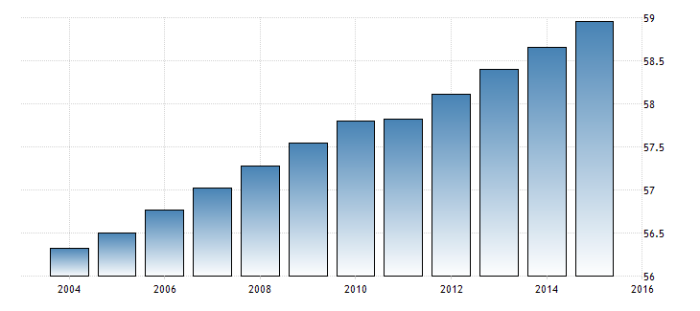

3. Planned construction

After World War II, intensive building activity begins, especially in Zagreb. Construction is related to the new ideology of conditional political change after the war, turning to socialism. Immediately after the war, the emphasis is on the planning and construction of the new procedures in urban planning.
- Novi Zagreb- In 1961. Census showed less than 3,500 inhabitants. Today, this number grew up to more than 110 000 inhabitants. It has become a modern and highly urbanized neighbourhood dominated by large apartment buildings and skyscrapers. The Museum of Contemporary Art, the Faculty of Civil Engineering, the sports centre Arena Zagreb, the shopping centres Avenue Mall and Arena Centre, the Zagreb Fair and the Hippodrome are just some of the many significant buildings in Novi Zagreb.
- Središće – A residential and office block to a maximum of nine floors above ground and several underground levels will soon be built, right next to the Museum of Modern Art in New Zagreb district centres.

Comparison of minimum requirements for energy efficiency to new and existing buildings with cost-optimized requirements
Sensitivity analysis on the variable component of the budget (the discount rate, the growth rate of energy prices, the current increase in energy prices and the use of only non-renewable component factors of primary energy) has determined a relatively large range of optimal levels for existing buildings
This is the result of significantly lower energy prices than the average value in an environment with a relatively high value of construction work (in fact, the technology used by existing older buildings are now significantly more expensive, and less accessible than at the time of their construction, which increases the costs of intervention on them), the high cost of capital - rated and the discount rate, and the real interest rate for micro-economic calculation.

4. Difference between coastal and continental Croatia

4.1 Continental Croatia

Good thermal insulation is the key to a pleasant climate. Due to that, investing in a quality facade is very important. The estimations of energy savings depend on many factors, but, for example, showed that a house with no façade uses about 60 percent more energy than one with a façade.
There are a number of standards which determine the thickness of certain materials and thermal insulation materials. One of the important factors that we take into consideration during the design is the climate in which the building is situated. The standards are different for continental and coastal parts of Croatia.
The thickness of thermal insulation affects the materials from which the house is built and the attic or cellar spaces and garage (which is integral part of the building) are heated or not.
On the roof structure, it is common to put mineral wool, timber and waterproof roof foil.
The selection on the covers, other than personal aesthetics, is sometimes generated by a roof pitch and climatic conditions. For instance, in continental Croatia during the winter, the roof pitch helps to redistribute the snow's weight. The ideal slope for a roof in especially snowy parts of the country is one that is steep enough to cause the snow to slide off the roof quickly and prevent it from accumulating. Roofs with shallow pitches are likely to retain snow, and the accumulating weight can cause the roof to fail.
There is also important to mention the importance of building so called „passive houses“. It is a building that is truly energy efficient, comfortable, affordable and ecological at the same time. Passive Houses are also praised for their high level of comfort. They use energy sources inside the building such as the body heat from the residents or solar heat entering the building – making heating a lot easier. Passive house is the most provable and performable conceptual platform for the self-sufficient architecture. Croatia has built 21 passive houses, so far. The family house “M4” is the first passive house in Croatia realized at the end of 2005 in Bestovje, a small place close to Zagreb. The owner started to use the house in the beginning of 2006. The author made redesign of existing project to maximize energy efficiency on the level of passive house standard. Residents of the houses use 80 percent less energy for heating and cooling than in conventional homes. Europe is already occurred 150,000 residential and commercial buildings. This is very useful during cold weather that can occur in continental parts of Croatia.
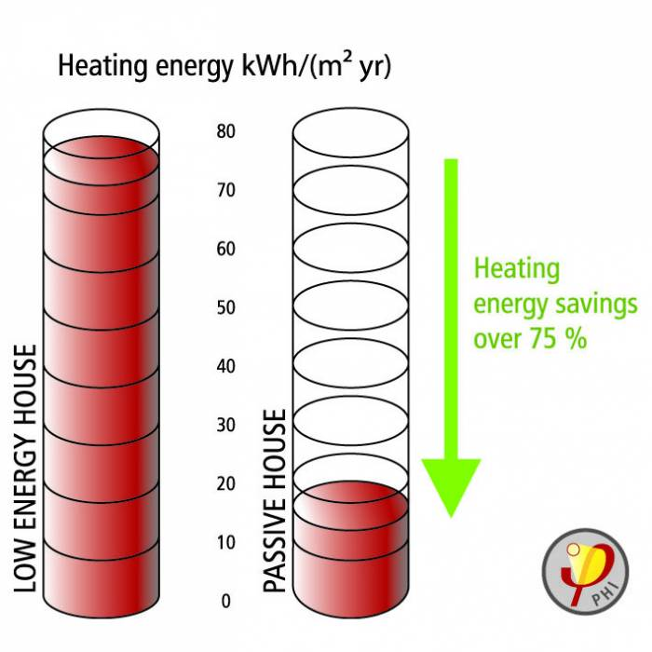

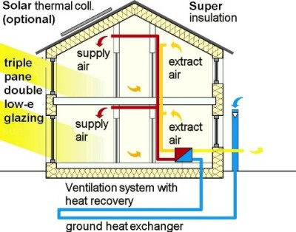

4.2. Coastal Croatia

The national revival in the nineteenth century encouraged a special interest in traditional rural architecture. In that spirit, research into Croatian forms of architecture was initiated at the turn of the century. Themes and elements of indigenous architecture can be seen on single-family houses designed by some Croatian architects. The two dominant traditions, construction in stone and construction in wood, resulted in elements (silhouette, material, openings) characteristic of family houses in the Adriatic part. In the 1930s, the group of artists associated with the "Zemlja" movement, although composed of people who promoted modern architecture, also emphasized the character of the home soil and environment. Some designs were completely different from usual flat-roofed modern houses. The tourist boom in the sixties strengthened interest in the regional, the local, and in the coastal belt this led to many designs of single-family houses with a fragmented volume and an emphasis on roof variety. Massive dark, sometimes fanciful, ìcapsî appeared in the interior as a sign of the local style. Today, almost every slanting roof is experienced as a traditional element, which makes it is easiest to communicate with the sensibilities of the general public through the appearance of the roof. In the overall development of family house architecture, traditional elements were always present, but in different ways - sometimes as direct association, sometimes included in the new vocabulary. The traditional was always needed in the field of single-family houses, but the measure and manner in which it was included often allowed different interpretations and disagreement.
Considering that a coastal climate is defined by its winds. The symbol of Croatian architecture in the coastal area, the traditional green on the old stone house, is increasingly used in modern coastal architecture as a protection from the wind and sun. Moreover, important symbols are traditional sun protective elements –ears (auriculus) that can be found in Ston, Croatia. The Croatian islands can be dry. The sunniest island in Croatia is Hvar, which is sunny over 2700 hours per year. For this reason, protective element called ears were very useful at that time because of the wind’s strength and aggression.

5. Associations of architects in Croatia

5.1. Croatian Association of Architects

Croatian Architects Association C.A.A. is a non-profit and non-government, professional, umbrella organization that consists of 11 member architectural societies. The total number of individual members of the C.A.A. member societies includes 2500 architects. C.A.A. has been active since 1878 and coordinates the architects’ professional interests on the territory of the Republic of Croatia, encourages development and affirmation of Croatian architecture and urbanism, culture of space, regional planning and environment protection.
C.A.A. is a publisher of two magazines on architectural issues: Arhitektura / Architecture (issued since 1947).
C.A.A. is a member of the International Union of Architects (UIA).

5.2. Croatian Chamber of Architects

Croatian Chamber of Architects establishes herself as the heir of the tradition and heritage of associations and organizations of architects, and continues the sequence of organized professional associations of architects in Croatia.
Chamber promotes architecture as an expression of the people and culture of creativity, enhances architectural activity in order to protect the public interest and the interests of third parties.
The idea for the design came from the architectural symbol of the fireplace. Fireplace, a gathering place, alludes to the chamber, or a gathering of people in one place, for the purpose of promoting and protecting their profession.
The sign has been modified into a cube that gives a national flavour, and is filled with a pattern that symbolizes concrete in architectural drawings, and therefore symbolizes strength, which is reflected in the efforts of the chamber to establish high professional standards. Moreover, the direction of the pattern indicates growth and progress.
As for colours, the entire identity rests on a blue coloration of the architectural drawings (blueprints), as blue is the colour of reliability, dependability stability and security, and is often associated with intellect and knowledge.

5.3. Croatia Green Building Council

Since it was founded in 2009 by 20 respected companies as a non-profit organization, the CGBC had gathered more than 100 members from the fields of architecture, construction, producers of construction materials and technologies, banking and insurance sector, as well as from professional and consulting institutions. We all think and act green, forming an important group of people who lead new trends and changes the picture of the environment in which we live and work.
CGBC is a part of the World Green Building Council (www.worldgbc.org) and the European regional network of GBC’s and we take place at many international, regional or local conferences, meetings, symposiums in cooperation with other Green Building Councils.
The goal of the CGBC and its members is to represent a national platform for the promotion of sustainable building practices trough different activities, and to be the drivers of positive change in Croatia in terms of sustainable development and green building. One of the main activities of the CGBC is to educate, and to spread the information and knowledge about planning and building of construction projects and their use with the goal of sustainability, taking in consideration the interests of those who use the facilities, environmental protection, social responsibility and economic viability. Therefore, the Green Building Council is organizing:
-Symposium for experts
-Better Building Brunch and Better Building Breakfast events
-Green Building Professional – yearly educational
-Educations for green building certifications (LEED; BREEAM; DGNB)
-Green Labs – daily interactive workshops
C-GBC take place on many conferences, fairs, symposiums and other events

5.4. ORIS
House of Architecture
Oris House of Architecture is a place of meetings, socialising, creativity and good vibrations; place for the promotion of architecture, design, art and culture. In the attractive area of over 600 m2, there is a multimedia hall, a readers‘ corner Forcimer, offices of the Oris magazine and the web portal, and the club restaurant Voncimer.
A multimedia hall with 156 seats is designed for professional lectures, seminars, conferences, presentations of products and services, exhibitions, cultural manifestations and workshops.
The library and the readers’ corner Forcimer, apart from its publications, offers more than 150 foreign and domestic magazines and numerous architectural and cultural monographs.
The guests of the restaurant Voncimer have the pleasure of sitting in unique chairs which were donated by architects from all parts of the world.
Magazine
The editorial concept of the magazine is based on the promotion and evaluation of buildings of cultural significance. Since it was launched, the magazine has been focusing on architecture produced by outstanding individuals and highly valuable works, with certain emphasis on the Middle-European context. There has been a continuous aspiration to retain the balance of presentations of regional and international works in order to explore relations and connections between local and foreign practices, regarding global, international tendencies, or regional scenes.
Oris magazine has been established in 1998 and it covers the media space of Croatia, Slovenia and Bosnia-Herzegovina. The magazine introduces an international selection of projects with an emphasis on works from the region. In addition, a separate section covers topics of art in general such as event-art, photography, music etc.
Days of Oris
“The Days of Oris” is an architectural convention which takes place every year since 2000. It is a two-day event with lectures of prominent international and local architects. The convention takes place at the Vatroslav Lisinski Concert Hall and has about two thousand visitors.
Next to mentioned big Days of Oris, national Days of Oris (Spanish, Finnish, Japanese, Portuguese, and French) regularly take place in Zagreb and Dubrovnik. Days of Oris have been organised in Ljubljana and Belgrade and in 2012, the Days of Oris were held in Hotel Lone in Rovinj.
World famous architects, but also radical and experimental authors, have spoken at the Days of Oris. So far, Oris has welcomed more than 200 speakers from all over the world.
The concept of Days of Oris is supplemental to the magazine and the selection of speakers is the result of the prevailing international importance of the magazine and the network of associates and authors which Oris has developed through the years. Days of Oris always aim towards the balance of already established and new authors, as well as the generational and conceptual variety of speakers.
ORIS d.o.o.
Headquarters
Prilaz Gjure Deželića 61
10 000 Zagreb

ORIS - HOUSE OF ARCHITECTURE
Headquarters
Prilaz Gjure Deželića 61
10 000 Zagreb
ORIS d.o.o. i ORIS - HOUSE OF ARCHITECTURE

Office
Kralja Držislava 3
10 000 Zagreb
Phone: +385 1 3778 177
Fax : +385 1 3756 243

6. Education in Croatia

6.1. Faculty of Architecture, University of Zagreb

The Faculty of Architecture continues the 85-year-long tradition of architect education in Croatia, implemented through university study programs, research and professional and artistic work in the fields of architecture and urban design.
The Faculty aims to prepare young experts to approach the complex and demanding issues of architecture and urban design in an informed, creative and responsible manner in the context of our time. The study program includes introduction to theoretical and practical knowledge of various relevant disciplines, encouraging the development of creative and intellectual skills and reasoning, introduction to the fundamentals and methods of scientific research, as well as learning through practical architectural and urban design. The Faculty of Architecture nourishes a broad tradition of engineering professions, supplementing them with artistic principles and considerations and expanding them with work methods characteristic to the processes of architectural design.
The study of architecture and urban design is a five-year-long program divided into two cycles with the aim of achieving comparability, mobility and better profiling of students’ interests. It ends with the title of Master of Architecture and Urban Design, which responds to the needs of the society, relevant legislation, EU directives and standards of professional associations which award professional licenses.
Kačićeva 26, 10000 Zagreb, Hrvatska
Tel.: 01 46 39 222
Fax: 01 48 28 079
URL: www.arhitekt.hr
E-mail: infoaf@arhitekt.hr

6.2. Faculty of Architecture- School of Design, University of Zagreb

The School of Design was founded in the spring of 1989 as an interdisciplinary study program at the Faculty of Architecture, in cooperation with the Academy of Fine Arts, the Graduate School of Economics and Business, the Faculty of Mechanical Engineering and Naval Architecture, the Faculty of Philosophy and the Faculty of Forestry. It was the result of long-term efforts to establish an interdisciplinary study program for training in the fields of industrial design and visual communications design. Today, the School realizes this aim by providing university study programs, conducting research, professional work and artistic activity in the field of design. The study program has continued the finest traditions of theoretical thought and principles of methodology and engineering, which have been present in the Croatian cultural and academic context since the late 1940s. Design is a creative activity whose aim is to establish the multi-faceted qualities of objects, processes, services and their systems in whole life cycles (according to ICSID, the International Council of Societies of Industrial Design, and ICOGRADA, the International Council of Graphic Design Associations).
Therefore, design is the central factor of innovative humanization of technologies and the crucial factor of cultural and economic exchange. The School of Design is a member of both these international organizations, which allows for the exchange of state-of-the-art experiences in its field of education. The study program is organized in accordance to the Bologna reform of the higher education system. It includes a three-year-long program of undergraduate study (Bachelor) and a two-year-long program of graduate study (Master of Design) in the fields of industrial design and visual communications design. Interest in the study of design is continuously present due to the needs of the labor market and the field’s social and economic importance for both the private and public sectors.
Frankopanska 12
10000 Zagreb
Tel: +385 1 48 48 560
Fax: +385 1 48 48 560
URL: www.studijdizajna.com
E-mail: sd@studijdizajna.arhitekt.hr

6.3. Faculty of Civil Engineering, Architecture and Geodesy, University of Split

The tradition of higher education in the field of Civil Engineering in Split began in 1971 with the founding of the Department of Civil Engineering as part of the University of Zagreb. The institution started to exist autonomously in 1977 as the Faculty of Civil Engineering Science of the University of Split. Since July 1991, the Faculty of Civil Engineering of the University of Split has been functioning as an independent higher education and scientific research organization. After the establishment of the Architectural Study in September 2003, the present-day Faculty of Civil Engineering and Architecture was founded. The Faculty has had its own building since the day it was founded. It covers an area of 8400 m2 which is used for halls, lecture halls, student study rooms, offices, laboratories, a library, and a conference room. Courses and scientific research are carried out in 21 departments and 5 centres.
The Faculty was coordinator of a project called “The development of higher occupational standards and qualifications standards in the field of sustainable and green building with the development of a new university graduate programs sustainable and green building with a focus on the Mediterranean area”.
Matice hrvatske 15
21000 Split, Croatia
Tel.
Switchboard: (+385) (21) 30 33 33
Student Office: (+385) (21) 30 33 03, (+385) (21) 30 33 75
General Secretary: (+385) (21) 30 33 04
Fax: (+385) (21) 46 51 17
Dean: Assoc. Prof. Boris Trogrlić, Ph.D.

6.4. Faculty of Civil Engineering, University of Osijek, University of Osijek- Architecture and urban planning

In 1967 in Osijek was established department of Technical college Zagreb. Faculty was established in 1976 under the name High technical school of the University of Osijek by local professionals and personnel, engaged in the teaching at the department. At first the school acted independently and then within the School of civil engineering in Osijek. In the mid-1982 it started to exist autonomously as a High civil engineering school Osijek. Since February 1992 it has been functioning autonomously, as the Faculty of Civil Engineering, University of Osijek. In 2005 the faculty received a permit to perform the contemporary studies of Civil Engineering conformed to the Bologna Declaration.
Vladimira Preloga 3
31000 Osijek
Tel.: +385 31 540 070 - Fax: +385 31 540 071

Architects in Croatia

(Country code +385 – remove 0 from the area code)
- Alavuk Pustijanac Bojana
dipl.ing.arh., 3369 ARHI D.O.O.
Rizzijeva 34, Pula (52100)
Tel: +385 52/507-124, Fax: +385 52/380-166
Email: bojana@arhi.hr

- Alivojvodić Ante
dipl.ing.arh., 2041 ARHITEKTURA ALIANTE D.O.O.
Lojenov prilaz 8, Zagreb (10000)
Tel./fax: +385 1 5509-586, Mob: +385 91 6805-060
Email: aliante@vip.hr

- Artuković Tanja
dipl.ing.arh, 3264 PO-MARK D.O.O.
Gustava Krkleca 40, Zagreb (10000)
Tel: +385 1 3888-873, Fax: +385 1 3888-874
Email: tanja@pomark.hr

- Asić Rutar Marija
ing.arh., 1007 RAPIDOGRAF D.O.O.
Travanjska 22, Zagreb (10000)
Tel: +385 1 3872-681, Fax: +385 1 3872-681
Email: marija.asic-rutar@rapidograf.hr
- Babić Vujić Zrinka
dipl.ing.arh, 3287 CRTAONICA D.O.O.
Ulica grada Mainza 32
Tel./fax: +385 1 371-1716, Mob: +385 98 179 5537
Email: zrinka.vujic@gmail.com

- Bajić Đurđica
dipl.ing.arh., 2210 COART D.O.O.
Vjećnička 2B, Koprivnica (48000)
Tel: +385 48 221-991, Fax: +385 48 621-007
Email: durdica.bajic@coart.hr

- Balić Dina
mag.ing.arch., 4058 DINATRONIC D.O.O.
Trg Petra Zrinskog 10, Vrbovec (10340)
Tel: +385 1 2793-025, Fax: +385 1 2791-648, Mob: +385 98 9619-279
Email: dina.balic@dinatronic.hr

- Batina Bulić Marija
dipl.ing.arh., 3861 ARHITEKTONSKI BIRO M+ D.O.O.
Antofogaste 14, Split (21000)
Tel: +385 98 644-469
Email: marija.batina1@gmail.com

- Bedenicki Željko
ing.građ., 1277 BEDENICKI PROJEKTNI BIRO D.O.O.
D.Cesarića 132, Varaždin (42000)
Tel: +385 42 206-674, Fax: +385 42 206-675
Email: bpb@vz.t-com.hr

- Begonja Ivan
dipl.ing.arh., 4156 B PLUS ARHITEKTI J.D.O.O.
Dinka Šimunovića 21, Split (21000)
Tel: +385 21 782-030, Mob: +385 91 4343-943
Email: ivan@bplusarhitekti.hr

- Bencetić Josip
ing.građ., 1011 ARHING D.O.O.
Gažanski Trg 8, Karlovac (47000)
Tel./fax: +385 47 611-861;611-899
Email: arhing@ka.t-com.hr
- Bibulić Sanja
mag.ing.prosp.arch., 4327 STUDIO K.A.P.P.O. D.O.O.
Centener 40, Rovinj (52210)
Tel: +385 52830-001
Email: lido@studio-kappo.com

- Bilandžić Igor
dipl.ing.arh., 1412 ARHITEKTURA I TOČKA D.O.O.
Gundulićeva 57, Zagreb (10000)
Email: info@jurajkralj.com

- Birov Tena
mag.ing.prosp.arch., 3688 OIKON D.O.O.
Trg Senjskih Uskoka 1-2, Zagreb (10000)
Tel: +385 1 5507-168, Fax: +385 1 5507-101
Email: tbirov@oikon.hr

- Bišćan Kristina
mag.ing.arch., 4189 MPI MONTKEMIJA-INŽENJERING D.O.O.
Ante Topić Mimare 30, Zagreb (10000)
Tel: +385 1 373-3074, Fax: +385 1 3733-116, Mob: +385 91 3733-077
Email: kristina.biscan@damin-plan.hr

- Blažević Danijela
dipl.ing.arh., 3641 HIDROPLAN D.O.O.
Horvaćanska 17/A, Zagreb (10000)
Tel: +385 1 3640-529, Fax: +385 1 3680-800
Email: hidroplan@hidroplan.hr

- Bognar Marta
dipl.ing.arh., 3697 ALTER LEGO STUDIO D.O.O.
Voltićeva 3, Pula (52100)
Tel: +385 99/2256-718
Email: infohr@alterlego.eu

- Bosna Vukičević Lada
dipl.ing.arh., 2310 PROJEKTNI BIRO SPLIT D.O.O.
Ivana Gundulića 42, Split (21000)
Tel: +385 21 343-051, Fax: +385 21 343-123
Email: pbs@pbs.hr

- Brakus Zoran
dipl.ing.arh. 112 BRAKUS D.O.O.
Zagrebačka 38, Varaždin (42000)
Tel: +385 42 204-370, Fax: +385 42 204-371
Email: brakus@brakus.hr

- Brala Martina
dipl.ing.arh., 2995 VOLAT J.D.O.O.
Jadranska 17/A, Posedarje (23242)
Tel./fax: +385 23 266-620, Mob: +385 98 662-266
Email: martina.brala@gmail.com

- Budanko Teo
dipl.ing.arh., 2432 ABWD D.O.O.
Trg žrtava fašizma 5, Zagreb (10000)
Tel: +385 1 3750-844, Fax: +385 1 3750-847
Email: abwd@abwd.hr

- Cetina Neda
dipl.ing.arh., 3401 INNOVARE D.O.O.
Giardini 6, Pula (52100)
Tel: 052/651-484, Mob: 091/321-7080
Email: neda.cetina@gmail.com , innovare.doo@gmail.com

- Cimaš Boris
dipl.ing.arh., 3210 CIMAŠ ARHITEKTURA D.O.O.
Ciottina 16, Rijeka (51000)
Tel: 051/321-536, Fax: 051/321-537
Email: boris@cimasarh.hr

- Cimaš Ines
dipl.ing.arh., 2826 CIMAŠ ARHITEKTURA D.O.O.
Ciottina 16, Rijeka (51000)
Tel: 051/321-536, Fax: 051/321-537
Email: info@cimasarh.com

- Cota Milivoj
Dipl.ing.arh., 3884 COTA I COTA D.O.O.
Strojarska 6, Zagreb (10000)
Tel: 01/6119-171, Fax: 01/6119-171, Mob: 098/9103-327
Email: cotaicota@gmail.com

- Cvitak Filip
dipl.ing.arh., 3554 AGRO-INŽENJERING D.O.O.
B.Magovca 20/B, Zagreb (10000)
Tel: 01/4811-566, Fax: 01/4811-577
Email: a-i@a-i.hr

- Dejanović Branka
dipl.ing.arh., 2436 INTER ART D.O.O.
Marmontova Aleja 18, Karlovac (47000)
Tel: 047/416-689, Fax: 047/416-689
Email: inter-art@ka.t-com.hr

- Čizmok Damir
dipl.ing.arh., 3110 FAROS PROJEKT D.O.O.
Jelsa Bb, Jelsa (21465)
Tel: 021/761-945, Fax: 021/761-945
Email: damir_cizmok@t-2.net

- Čop Tomislav
dipl.ing.arh., 3848 TOMISLAV COP ATELJE D.O.O.
Ivana Gundulića 45, Zagreb (10000)
Tel: 099/5620-690
Email: tomislavcop@tomislavcop.com

- Ćalić Dragica
dipl.ing.arh., 3590 PORTICUS D.O.O.
Kocunarski prilaz III/4, Split (21000)
Tel: 021/389-913, Fax: 021/389-913
Email: dragica.calic@inet.hr

- Dejanović Branka
dipl.ing.arh., 2436 INTER ART D.O.O.
Marmontova Aleja 18, Karlovac (47000)
Tel: 047/416-689, Fax: 047/416-689
Email: inter-art@ka.t-com.hr

- Đekić Branka
dipl.ing.arh., 2371
Opširnije o članu V.G. NADZOR D.O.O.
Velikogorička Cesta Bb, Vukovina (10419)
Tel: 01/6230-591, Fax: 01/6230-592
Email: vgnadzor@vgnadzor.hr

- Gačić-Pojatina Alenka
dipl.ing.arh., 1602 AGP DIZAJN D.O.O.
4. Malešnica 22, Zagreb - Susedgrad (10090)
Tel: 01/3733-410, Fax: 01/3733-410
Email: agp.dizajn@inet.hr

- Galić Velinka
dipl.ing.arh., 1799 ZAJEDNIČKI PROJEKTANTSKI URED VELINKA GALIĆ I NIKOLINA ŠABAN
Spinčićeva ulica 25, Split (21000)
Tel: 021/389-408, Fax: 021/389-408, Mob: 098/1767-399
Email: velgalic@inet.hr

- Galošić Matija
dipl.ing.arh, 3269 CRTA D.O.O.
Ulica Zatonskih Stanova 13, Zaton, Nin (23232)
Tel: 023/779 -105, Fax: 023/779-051
Email: crta@crta.hr

- Gambin Iva
mag.ing.arch., 4199 ARH.BIRO-02 D.O.O.
Mletačka 12/Iv, Pula (52100)
Tel: 052/210-616
Email: arhbiro02@gmail.com

- Gatara Goran
dipl.ing.arh., 3474 IVICOM CONSULTING D.O.O.
Damira Tomljanovića Gavrana 11, Zagreb (10000)
Tel: 01/6286602, Mob: 099/2271456
Email: goran.gatara@ivicom.hr

- Grediček Damir
dipl.ing.arh., 842 GREDA PROJEKT D.O.O.
Korčulanska 10/3, Zagreb (10000)
Tel: 01/6187-420, Fax: 01/6181-299
Email: greda.projekt@zg.t-com.hr

- Grubeša Željka
dipl.ing.arh., 3762 ALVIR D.O.O.
11. Podbrežje 25, Zagreb (10000)
Tel: 01/6558-045, Fax: 01/6558-044
Email: alvir@zg.t-com.hr

- Guć Jurica
mag.ing.arch., 4006 HEROS D.O.O.
Mike Tripala 10, Split (21000)
Tel: 021/246-830, Fax: 021/246-839, Mob: 098/464-847
Email: info@heros.hr

- Gudelj Julija
mag.ing.arch., 3913 INK PROJEKT D.O.O.
Višnjevac 18, Zagreb (10000)
Tel: 01/3015-156, Fax: 01/3015-156, Mob: 095/1999-216
Email: julija.plecas@inkprojekt.hr

- Hršak Vesna
dipl.ing.arh., 1318
ARTING D.O.O.
Strossmayerova 4, Bjelovar (43000)
Tel: 043/241-226, Fax: 043/221-471
Email: arting@bj.t-com.hr

- Jakopec Sandra
dipl.ing.arh., 2754 APE D.O.O.
Ozaljska 61, Zagreb (10000)
Tel: 01/3011-427, Fax: 01/3097-572
Email: sandra.jakopec@ape.hr

- Jović Svjetlana
dipl.ing.arh., 1456 APIS D.O.O.
Nova Cesta 48, Zagreb (10000)
Tel: 01/3820-993, Fax: 01/3821-011
Email: svjetlana.jovic@apis.hr

- Jović Danko
mag.ing.arch., 4284
TOGA - INŽENJERING D.O.O.
Ladiševa 9, Zagreb (10000)
Tel: 01/3456-111, Fax: 01/5435-213
Email: togaing@togaing.hr

- Južnić Andrina
dipl.ing.arh., 1303 ZO-INVEST D.O.O.
Mirogojska 16, Zagreb (10000)
Tel: 01/4678-261, Fax: 01/4678-261, Mob: 091/4629-909
Email: andrina.juznic@zoinvest.hr

- Kahrović Emir
dipl.ing.arh., 3773 KOTA 1234 D.O.O.
Stupovlja 7, Dunave (Općina Konavle)
Email: emir.kahrovic@gmail.com

- Kalaš Zajc Barbara
dipl.ing.arh., 3716 BIRO-GRADNJA D.O.O.
Belečka 3, Zagreb (10000)
Tel: 01/3698 198, Fax: 01/3097-818
Email: info@birogradnja.hr

- Kanceljak Marelić Melita
dipl.ing.arh., 823 PROJEKTNI URED KANCELJAK MARELIĆ D.O.O.
Lješnjakovec 1, Zagreb (10000)
Tel: 01/2337-314, Fax: 01/2337-313
Email: projektni.km@zg.t-com.hr

- Katić Ante
mag.ing.arch., 4112 MAT PROJEKTNI STUDIO D.O.O.
Zagrebačka avenija 3, Zagreb (10000)
Email: matstudio@mail.com

- Kedžo Hrvoje
dipl.ing.arh., 4016 ALITE J.D.O.O.
Slobode 3, Split (21000)
Mob: 091/1656-319
Email: alite.arhitektura@gmail.com

- Kelemin Ana
mag.ing.arch., 2886 ENTASIS PROJEKT D.O.O.
Antunovac 34, Zagreb (10000)
Tel: 01/3703-496, Fax: 01/376-559, Mob: 091/9141-435
Email: ana.kelemin@zg.t-com.hr

- Kljaić Zorka
ing.građ., 1394 STRUKTURA PROJEKT D.O.O.
Ivana Adamovića 4, Osijek (31000)
Tel: 031/210-277, Fax: 031/200-990
Email: struktura@os.t-com.hr

- Kljajić Višnja
dipl.ing.arh., 2024 ZEMLJANA GRUPA D.O.O.
Bjelovarska 3, Sesvete (10360)
Tel: 01/2009-400, Mob: 091/2009-401
Email: visnja.zemljana@gmail.com

- Kostić Tihomir
mag.ing.arch., 4225
EKOLOŠKI CENTAR D.O.O.
Parobrodarska 5, Vukovar (32000)
Tel: 032/444-005
Email: eko@ekocentar.hr

- Krkalo Mrvelj Iva
dipl.ing.arh., 2773 PLANISFERA D.O.O.
Črna Voda 38A, Zagreb (10000)
Tel: 01/4586-426, Fax: 01/4586-426
Email: planisfera@gmail.com

- Kučan Smešny Mara
dipl.ing.arh., 3522 URBANISTIČKI STUDIO RIJEKA D.O.O.
Strossmayerova 3/Ii, Rijeka (51000)
Tel: 051/374-007, Fax: 051/327-232
Email: urb-studio-ri@ri.t-com.hr

- Kudić Edin
dipl.ing.arh, 3273
KUDIĆ PROJEKT D.O.O.
Velog Jože Br6, Pula (52100)
Tel: 091/142 5451
Email: kudic_project@hotmail.com

- Kulišić Ivan
dipl.ing.arh., 3896 MARTON KONCEPT D.O.O.
Odvojak matije Gupca 1, Konjščina (49282)
Tel: 01/2009-152, Mob: 098/1773-457
Email: martonarhitektura@gmail.com

- Kurtić Sead
dipl.ing.arh., 3626 ADING-PROJEKT D.O.O.
Vitezićeva 62, Zagreb (10000)
Tel: 01/2304-878, Fax: 01/2304-878, Mob: 091/9591-277
Email: ading.projekt@gmail.com

- Ladić Josip
dipl.ing.arh., 3293 TLORIS D.O.O.
Malomlačka 122, Zagreb (10000)
Tel: 01/5573-640, Mob: 098/9062-883
Email: josip@tloris.hr

- Lasinović Damir
dipl.ing.arh., 2738 ARX D.O.O.
Stara Cesta 4, Šibenik (22000)
Tel: 022/216-060, Fax: 022/200-116
Email: arx@studioarx.hr

- Lazarić Toni
mag.ing.arch., 4226
KONZOLA ARHITEKTURA J.D.O.O.
Epulonova 17, Novigrad (Cittanova) (52466)
Mob: 098/592-127
Email: tonilazaric@gmail.com

- Levačić Blanka
mag.ing.arch., 4276 FOTOFAN D.O.O.
Trg slobode 2, Varaždin (42000)
Mob: 098/814-015
Email: blanka_levacic@yahoo.com

- Lisac Barbaroša Goranka
dipl.ing.arh., 3366 PLANOTEKA D.O.O.
Antuna Stipančića 22, Zagreb (10000)
Tel: 01/3881-238, Fax: 01/3881-534, Mob: 091/5664-556
Email: glb.planoteka@gmail.com

- Lukić Ivan
dipl.ing.arh., 4136 LUKIĆ PROJEKT D.O.O.
Slavonska 11, Makarska (21300)
Tel: 021/613-548, Fax: 021/613-548
Email: lukic-projekt@st.t-com.hr

- Maksan Emina
dipl.ing.arh., 1699
AXA D.O.O.
Šet.Kneza Branimira 2, Biograd n/m (23210)
Tel: 023/384-759, Fax: 023/384-759, Mob: 098/331-047
Email: axa@zd.t-com.hr

- Mamula Mirna
dipl.ing.arh., 3101 NEXT PROJEKT J.D.O.O.
Južna obala VII. 23, Zagreb - Novi Zagreb (10020)
Mob: 098/286-905
Email: nextprojekt76@gmail.com

- Mandić Bukulin Ivana
dipl.ing.arh., 3518 ACES D.O.O.
Antuna Barca 7C, Zadar (23000)
Tel: 023/244-850, Fax: 023/244-867
Email: aces@aces.hr

- Marić Marija
dipl.ing.arh., 4172 Z-PROFIL D.O.O.
Lašćinske ledine 27, Zagreb (10000)
Tel: 01/234-7330, Mob: 098/481199
Email: z-profil@zg.t-com.hr

- Marov Bogdan
dipl.ing.arh., 839 RENE D.O.O.
Obala Kneza Trpimira 36, Zadar (23000)
Tel: 023/334-039, Fax: 023/337-739
Email: bobo@rene.hr

- Matušin Tomislav
mag.ing.arch., 4027 UMMA D.O.O.
Frane Alfirevića 6, Zadar (23000)
Mob: 099/797-1814
Email: umma@net.hr

- Melić Davor
dipl.ing.arh., 2492 ARHITEKA D.O.O.
Mirka Seljana 30, Karlovac (47000)
Tel: 047/415-710, Fax: 047/415-710
Email: arhiteka@ka.t-com.hr

- Meštrović Slavica
dipl.ing.arh., 1980 PLANE DVA D.O.O.
Nad Lipom 12 B, Zagreb (10000)
Tel: 01/3769-135, Fax: 01/3769-135
Email: slavica.mestrovic@planedva.com

- Miklo Joško
mag.ing.arch., 3618 ALFAPLAN D.O.O.
Marka Marojice 3, Dubrovnik (20000)
Tel: 020/332-700, Fax: 020/332-404
Email: josko.miklo@alfaplan.hr

- Mikša Radmila
dipl.ing.arh., 2792 VPS - INŽENJERING D.O.O.
Prespanska 25, Zagreb (10000)
Tel: 01/3012-063;3012-064, Fax: 01/3012-201
Email: vps-inzenjering@zg.t-com.hr

- Mimica Frane
mag.ing.arch., 4328 AFM GRUPA J.D.O.O.
Tijardovićeva 6, Split (21000)
Mob: 097/7662-904
Email: afmgrupa@gmail.com

- Mraz Suzana
dipl.ing.arh., 2622 D.S.-STILUS D.O.O.
Grahorova 6, Zagreb (10000)
Tel: 01/3455-471, Fax: 01/3455-471, Mob: 091/2502-736
Email: suzana.mraz@zg.t-com.hr, info@ds-stilus.hr

- Muhvić-Pintar Damir
dipl.ing.arh., 1977
Opširnije o članu PINTAR-M D.O.O.
Šljivik 24, Zagreb (10000)
Tel: 01/2347-550, Fax: 01/2348-277
Email: damupi1@gmail.com

- Musić Tihana
Dipl.ing.arh., 3598 TISSA D.O.O.
Massa Lombarda 26, Poreč (52440)
Tel: 052/431-552, Fax: 052/423-010
Email: tissa@tissa.hr

- Novak Vesna
dipl.ing.arh., 1199 URBIS D.O.O.
Trg Josipa Runjanina 15, Vinkovci (32100)
Tel: 032/332-880, Fax: 032/332-880, Mob: 095/906-1001
Email: vesna.novak@vk.t-com.hr

- Parać Marko
dipl.ing.arh., 809 ART PROJEKT D.O.O.
Paraći 52, Solin (21210)
Tel: 021/217-229, Fax: 021/217-229
Email: artprojekt@email.htnet.hr

- Peruzović Mario
dipl.ing.arh., 2382 3MIK STAN D.O.O.
Gospodska 11, Zagreb (10000)
Tel: 098/358-100, Mob: 098/203-019
Email: 3mikstan@gmail.com

- Pfarrer Lidija
dipl.ing.arh., 2851 PFARRER PROJEKT D.O.O.
Graberje 9, Zagreb (10000)
Tel: 01/3701-272, Fax: 01/3740-873
Email: lidija@pfarrer-projekt.hr

- Pleša Zvonimir
ing.arh., 545 GRADNJA D.O.O.
Ribarska 1, Osijek (31000)
Tel: 031/235-000, Fax: 031/235-035
Email: gradnja@gradnja.hr

- Podrebarac Goran
dipl.ing.arh., 1509 RESCON D.O.O.
Ul.Josipa Kozarca 1/A, Čakovec (40000)
Tel: 040/395-771, Fax: 040/390-223
Email: goran.podrebarac@rescon.hr

- Polić Anamarija
dipl.ing.arh., 3193 ADRIAPROJEKT D.O.O.
Pomerio 7, Rijeka (51000)
Tel: 051/215-088, Fax: 051/215-088
Email: adria.p@ri.t-com.hr

- Potočnjak Žarko
dipl.ing.građ., 1095 POTOČNJAK D.O.O.
Verdieva 6, Rijeka (51000)
Tel: 051/312-035
Email: potocnjak@ri.t-com.hr

- Radošević Bojan
mag.ing.arch., 4325
ARHING D.O.O.
Gažanski Trg 8, Karlovac (47000)
Fax: 047/611-861; 611-899
Email: arhing@ka.t-com.hr

- Rakovac Tatjana
dipl.ing.arh., 444 URBANISTIČKI STUDIO RIJEKA D.O.O.
Strossmayerova 3/Ii, Rijeka (51000)
Tel: 051/374-007, Fax: 051 327 232
Email: urb-studio-ri@ri.t-com.hr

- Renuša Jagoda
dipl.ing.arh., 176 RENOVA D.O.O.
Ružičnjak 16, Zagreb (10000)
Tel: 01/4666-395, Fax: 01/4666-395, Mob: 098/220434
Email: renova@inet.hr

- Rukavina Goran
dipl.ing.arh., 1165 AREA ARTE D.O.O.
Ulica Grada Vukovara 237C, Zagreb (10000)
Tel: 01/6115-322, Fax: 01/6159-922
Email: areaarte@areaarte.hr

- Runjić Sanja
dipl.ing.arh., 3885 FIKCIJA D.O.O.
Torbarova 11, Zagreb (10000)
Mob: 099/615-2232
Email: sanja@fikcija.com

- Samardžić Tomislav
mag.ing.arch., 4312 OCTAPRO J.D.O.O.
Ž. Mihaljevića 4, Sisak (44000)
Mob: 091/5868-643
Email: tomislav.samardzic@octapro.hr

- Selaković Zdenko
dipl.ing.arh., 492 AING D.O.O.
Senjska 12, Karlovac (47000)
Tel: 047/612-024, Fax: 047/636-355
Email: aing@ka.t-com.hr

- Smirčić Doris
dipl.ing.arh., 2120 CUBUS D.O.O.
Ivana Mažuranića 21, Zadar (23000)
Tel: 023/494-555, Fax: 023/236-294
Email: doris@cubus-zadar.hr

- Sokačić-Kosović Silvija
dipl.ing.arh., 2988 KOSOVIĆ, D.O.O.
Henrija Dunanta 5, Zagreb (10000)
Tel: 01/379-2552, Fax: 01/379-2553, Mob: 098/860-861
Email: silvijakosovic@gmail.com

- Stanić-Siništaj Ursula
dipl.ing.arh., 3103 STUDIO LACROMA D.O.O.
Ispod Minčete 6, Dubrovnik (20000)
Tel: 020/311-128, Fax: 020/311-128
Email: ursula@studiolacroma.com

- Straga Vesna
mag.ing.arch., 4088 SPECULUM D.O.O.
Bartolići 49, Zagreb (10000)
Tel: 01/889-6765, Fax: 01/889-7039
Email: vesna.straga@speculum.hr

- Svilanović Goran
dipl.ing.arh., 3719
PROPORTIO D.O.O.
Višnjica 39, Zagreb (10000)
Tel: 01/3768-322, Fax: 01/3768-322
Email: proportio.zg@gmail.com

- Šantek Lidija
dipl.ing.arh., 3000 ARIS D.O.O.
Supilova 50 A/Iv, Varaždin (42000)
Tel: 042/207-620, Fax: 042/207-621
Email: lidijasantek@net.hr

- Šehić Nizar
ing.arh., 1297 CRTA PRO D.O.O.
Fanceljev Prilaz 9, Zagreb (10000)
Tel: 01/6601-356
Email: crta-pro@net.hr

- Šokman Matulić Jasmina
dipl.ing.arh., 834 STUDIO AEDIFICO D.O.O.
Vončinina 2, Zagreb (10000)
Tel: 01/3705-418, Fax: 01/3705-418
Email: jasminasokman@gmail.com

- Štrelov Kardum Maja
dipl.ing.arh., 2744 ARHITEKTONSKI STUDIO G&B D.O.O.
Jurkovićeva 3, Zagreb (10000)
Tel: 01/4633-908, Fax: 01/4633-023
Email: maja.strelov_kardum@gib.hr

- Šulina Iva
mag.ing.arch., 4264
Opširnije o članu RANDIĆ I SURADNICI D.O.O.
Trg Vladka Mačeka 6, Zagreb (10000)
Fax: 01/4839-018
Email: iva@randic.hr

- Tadić Diana
dipl.ing.arh., 4247 VESTRUM PROJEKT J.D.O.O.
Mornarska 24, Trogir (21220)
Mob: 099/2228-430
Email: vestrum.projekt@gmail.com

- Tošić Marin
mag.ing.arch., 4239 TAB ARCHITECTURE D.O.O.
P.Krešimira IV 2, Dubrovnik (20000)
Mob: 098/9593-795
Email: marintosic@gmail.com

- Toth Kozina Lujza
dipl.ing.arh., 2963 LTK STUDIO 1 D.O.O.
1.Ferenščica 53, Zagreb (10000)
Tel: 091/9094-682
Email: ltk@ltk-studio.com

- Vedrina Branko
dipl.ing.arh., 276 ARHING D.O.O.
Gažanski Trg 8, Karlovac (47000)
Tel: 047/611-861;611-899, Fax: 047/611-861;611-899
Email: arhing@ka.t-com.hr

- Veseljak Željka
dipl.ing.arh., 3245 STUDIO LINEAMENTA D.O.O.
Čulinečka Cesta 24 A, Zagreb (10000)
Tel: 01/3492-600, Fax: 01/3492-601
Email: studio@lineamenta.hr

- Vinski Matija
dipl.ing.arh., 3604
ARHITEKTURA VINSKI D.O.O.
Trg kralja Petra Svačića 1, Karlovac (47000)
Tel: 047/296-416, Mob: 098/365-240
Email: matija@arhitektura-vinski.hr

- Vudrag Joško
dipl.ing.arh., 3410
AV-CONSULTING D.O.O.
Gavanova 40, Šibenik (22000)
Tel: 022/215-685, Fax: 022/215-685
Email: av-consulting@si.t-com.hr

- Vukelić Marko
dipl.ing.arh., 4242 ARCHIDEA STUDIO J. D. O. O.
Ulica J.J. Strossmayera 15, Rijeka (51000)
Mob: 095/822-5498
Email: archideastudio.ri@gmail.com

- Zaninović Jagoda
dipl.ing.arh., 1626
ZARH D.O.O.
Sv.Krševana 6, Šibenik (22000)
Te./fax +385 22 337-690, Mob: + 385 91 5072-244
Email: zarh2010@hotmail.com

- Zorko Zoran
dipl.ing.arh., 263
PRIZMA D.O.O.
Potočka 32, Križevci (48260)
Tel: 048/681-105, Fax: 048/681-105
Email: zoran.z@hi.t-com.hr

- Žuvanić Maja
dipl.ing.arh., 3959
OPTIMA D.O.O.
Ante Starčevića 13/d, Zadar (23000)
Tel: 023/240-468, Fax: 023/240468
Email: maja.zuvanic@optima-zadar.hr

