The machinery in Croatia
APRIL 2016
Embassy of Belgium office@beltrade-croatia.com
Economic and Commercial Section Tel: +385 1 457 74 44
Pantovčak 125b1 Fax: +385 1 457 74 45
HR – 10000 Zagreb (Croatia)

Donald VOCHELLE and Raphaël DURAY
Interns at the Embassy of Belgium- Economic and Commercial Section
Table of contents
2.1 General overview 3
2.2 Geography 3
2.3 Political overview 4
2.4 Economic overview 4
2.5 Population 7
2.6 Demographics 7
3.1 Labor force 8
4.1 Introduction 11
4.2 Automation 12
4.2.1 Production 12
4.2.2 Regulations 13
4.2.3 14
4.2.4 14
4.2.5 Foreign trade 14
4.2.6 Employment figures 15
4.2.7 Privatization 15
4.2.8 Fairs 16
4.2.9 Associations 16
4.2.10 Industrial automation companies in Croatia 17

Overview of Croatia

General overview
Sources: www.dzs.hr
AREA | 56,594 km² (22,830 sq. mi)
POPULATION | 4 284 889
CAPITAL CITY | Zagreb
POPULATION IN ZAGREB | 790 017 inhabitants
LANGUAGE | Croatian
CURRENCY | Croatian Kuna (HRK)
GOVERNMENT | Parliamentary Democracy
PRESIDENT | Member of HDZ or Croatian Democratic Union, Kolinda Grabar-Kitarović was elected for a five-year term in January 2015
MEMBERSHIP OF INTERNATIONAL ORGANIZATIONS | - United Nations  - European Union  - Organization for Security and Co-operation in Europe  - Council of Europe  - Regional Cooperation council  - International Monetary Fund  - World Bank  - World trade Organization  - European Bank for Reconstruction and Development  - Partnership for Peace  - NATO

Geography

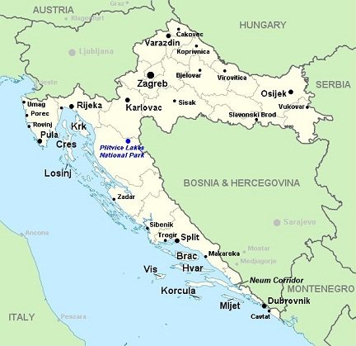

The Republic of Croatia is located in Southeast Europe covering a total of 56,610 km². Croatia is bordered by Slovenia, Hungary, Serbia, Bosnia-Herzegovina, Montenegro and Italy with which it shares a maritime border along the Adriatic Sea. The capital is Zagreb and other major cities are Split, Osijek, Rijeka, Zadar, Pula and Dubrovnik. The country is divided into 21 counties, which contain 124 towns.

Political overview

Formerly a major constituent part of Yugoslavia, Croatia declared independence in June 1991. Today, Croatia is a member of the European Union (EU), United Nations (UN), the Council of Europe, NATO, the World Trade Organization (WTO) and also the founding member of the Union for the Mediterranean. The current president of Croatia is Mrs. Kolinda Grabar Kitarović but the executive authority rests with the Prime Minister, Mr. Tihomir Orešković, who is appointed by the president and is accountable to the Parliament.

Economic overview

Before the global financial crisis of 2008-09, the Croatian economy grew at a healthy 4-5% annually, incomes doubled, and economic and social opportunities dramatically improved. The prolonged crisis put this progress, as well as Croatia’s aspirations, to the test, as the country struggled with six years of recession. The latest economic forecast expects Croatia to have a GDP growth of 2.1% in 2016 and 2017 along with an inflation of 0.3% in 2016 and 1.6% in 2017. Moreover, there will be an improvement in the public budget balance (% of GDP) increasing from -3.9 in 2016 to -3,2 in 2017.

The highest contribution to this growth comes from exports of goods and services. Declining oil and food prices and the personal income tax cut helped with the recovery of domestic demand, especially of personal consumption.

Croatia is a member of the IMF, the European Bank for Reconstruction & Development and the World Trade Organization. Croatia applied for EU membership in February 2003 and has worked hard to align its legislation with the EU acquis. The EU has provided Croatia with financial assistance in the areas of economic and social development, justice and home affairs, the building of administrative capacity and environmental protection, with a view to enable a smooth transition to European structures.

Tourism is a notable source of income, particularly during the summer months. With over 10 million foreign tourists annually, tourism generates revenue in excess of € 7 billion. Croatia is ranked amongst the top 20 most popular tourist destinations in the world, and was voted the world top tourism destination in 2005 by Lonely Planet. According to the site Best European Destinations, Zadar was voted best European destination in 2016, and Zagreb was voted for the best Christmas destination in 2015.

GDP – purchasing power parity: | €82,034 billion (2015)  €81,371 billion (2014)  €81,687 billion (2013)
GDP – per capita: | €19,347 (2015)  €19,246 (2014)  €19,246 (2013)
GDP – real growth rate: | 0.8% (2015)
GDP composition by sector: | agriculture:  industry:  services: | 4.3%  26.7%  69.1% (2015)
Labor force(employed): | 1,708 million (2015)
Labor force (by occupation): | agriculture:  industry:  services: | 1.9%  27.6%  70.4% (2015)
Unemployment rate: | 19.3% (2015)
Distribution of family income – Gini index: | 32 (2010)
Budget: | revenues:  expenditures: |  | €18,60 billion  €20,80 billion (2015)
Taxes and other revenues: | 41,9% of GDP (2015)
Budget surplus (+) or deficit (-): | -5% of GDP (2015)
Public debt: | 89.5% of GDP (2015)
Inflation rate (consumer prices): | -0.3% (2015)
Agriculture – products: | wheat, corn, sugar beets, sunflower seed, barley, alfalfa, clover, olives, citrus, grapes, soybeans, potatoes, livestock, dairy products
Industries: | chemicals and plastics, machine tools, fabricated metal, electronics, pig iron and rolled steel products, aluminum, paper, wood products, construction materials, textiles, shipbuilding, petroleum and petroleum refining, food and beverages, tourism
Exports: | €11,104 billion (2015)
Exports – commodities: | transport equipment, machinery, textiles, chemicals, foodstuffs, fuels
Exports – partners: | Italy 13.7%, Bosnia and Herzegovina 12%, Slovenia 11.2%, Germany 11.1%, Austria 6%, Serbia 5% (2014)
Imports: | €17,509 billion (2015)
Imports – commodities: | machinery, transport and electrical equipment, chemicals, fuels and lubricants, foodstuffs
Imports – partners: | Germany 15.1%, Italy 14.1%, Slovenia 10.7%, Austria 8.6%, Hungary 6.5%, Russia 5% (2014)
Debt – external: | €56,393 billion (2015)
Stock of direct foreign investment – at home: | €38,148 billion (2015)
Stock of direct foreign investment – abroad: | €7,004 billion (2015)
Sources: https://www.cia.gov/library/publications/the-world-factbook/geos/hr.html

Population

According to the Croatian Bureau of Statistics, the Croatian population is 4 284 889 million.
Zagreb City, the capital, is the country’s largest region, with a population of 790 017 according to the 2011 census, which equals to 17,6 % of the total population.
Population by age group, ethnicity and religion
Age | 65+ | 15-64 | 0-14
% of total population | 15,7% | 67,2% | 17,1%

Croatia is inhabited mostly by Croats (89,6 %), while minority groups include Serbs (4,5 %), Bosniaks, Hungarians, Italians, Slovenes, Germans, Czechs, Roma people and others (5,9 %). The average life expectancy is 75,1 years, and the literacy rate is 98,1 %. The main religions of Croatia are Roman Catholic 85 %, Orthodox 5 %, other Christian 0,4 %, Muslim 1,3 %, other and unspecified 0,9 %, none 5,2 %.

Demographics

Principal Demographic Indicators
 | 2001 | 2006 | 2011 | 2014
Live births  Rate/000 pop | 40,993  9.2 | 41,446  9.3 | 41,197  9.4 | 39,566  9.3
Deaths  Rate/000 pop | 49,552  11.2 | 50,378  11.3 | 51,019  11.9 | 50,839  12.0
Infant deaths | 315 | 215 | 192 | 199
Life expectancy  Males  Females | 71.1  78.1 | n/a  n/a | 73.9  80,0 | 74,6  80,5
Source: http://www.hzjz.hr/publikacije/hzs_ljetopis/, Croatian Health Service Yearbook 2014

Croatian industrial automation overview

The Croatian industrial sector is intensively changing and the effects of the full scale and strategically thought out restructuring of this sector are evident in many areas, from privatisation to the strengthening of exports to western markets, development of new products and innovations to existing products and manufacturing processes, to increasing the level and standardisation of quality, satisfying environmental protection conditions, reaching cost effectiveness, etc.
In July 2015, industrial output rose 3.9% over the same month last year in working-day adjusted terms coming above the June’s 1.6% increase. On a monthly basis, industrial production in July grew 3.6% in seasonally-adjusted terms, contrasting June’s 3.0% fall. The overall trend improved as annual average growth in industrial production inched up from June’s 1.6% to 1.8% in July. With more than €1 billion, the industrial sector in Croatia represents 27% of the country total’s economic output and this sector represents also 25% of Croatia’s GDP.
Industry remains the most important branch of the Croatian economy. The future of Croatian industry lies in the challenge of accessing new markets, introducing modern technologies and new products, as well as forming joint ventures and strategic partnerships with foreign companies. A skilled labour force and highly educated experts in engineering and computer technology supported through technology centres at the technical schools within Croatian Universities represent a good foundation for foreign investments in advanced technologies.

Labor force

Firstly, an interview of Croatia’s Minister of Labour and Pension System, Mirando Mrsic the 7th of March 2012:
"Croatia needs to have two million employees. That is the goal in ten or more years, but now is the time to initiate change, to start educating people for employable jobs, and not for the employment service which is the case now," said Mrsic speaking at the closing conference. Mrsic added that only two to three per cent of citizens were involved in an educational activity, and lifelong learning was precisely one of the measures which would match supply and demand for labour in the labour market.

The ministry of Science, Education and Sport Marija Lugaric began to work on a strategy for adult education because there would be a demand for highly educated workers in the future. She considers Croatia to have a good legislative framework with over 467 institutions, and as a member of the EU it would be able to count on enviable material resources for retraining workers, reported Croatian radio television.

Labour force of republic of Croatia, according to administrative sources and by sex
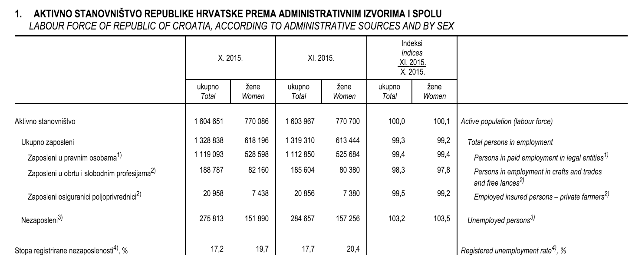

The registered unemployment rate has crept past 20 per cent after data for the month of February was released by the Central Bureau of Statistics yesterday (Thurs), reported Croatian radio television.
There was a 0.3 percentage point increase last month, taking the registered unemployment rate to 20.1 per cent.

The distribution of the main categories of economic activities of the population shows that the share of the working-age population, 2 399 000 of them in particular, or 66.6% of the total number in the Republic of Croatia, belonged to Continental Croatia, while Adriatic Croatia had 1 202 000 persons aged 15 or over, which accounted for 33.4% of the total working-age population in the country. In Continental Croatia, the share of economically active persons within the working-age population was 53.6%, which was higher than the Croatian average (52.7%), while Adriatic Croatia had 50.8% of active population. The employment rate in Adriatic Croatia was 42.8%, while in Continental Croatia it was 45.3%. Accordingly, the unemployment rate in Adriatic Croatia was 15.7%, which was a little bit higher than the Croatian average, while in Continental Croatia it amounted to 15.5%.

Classification of persons by employment

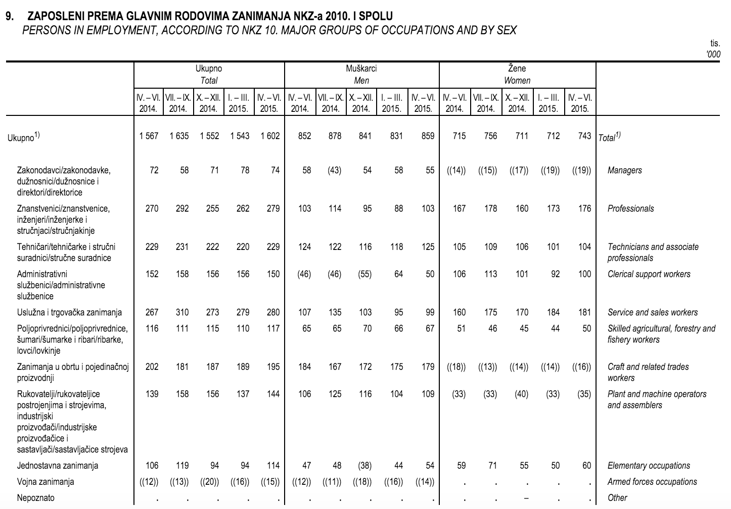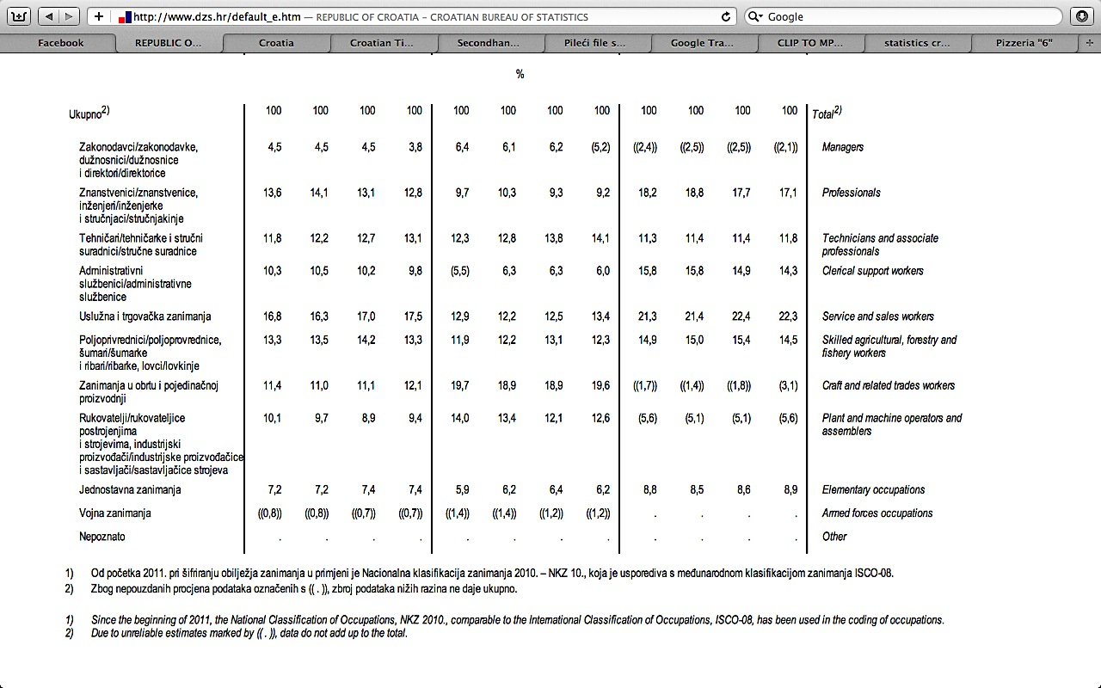

Limitation in work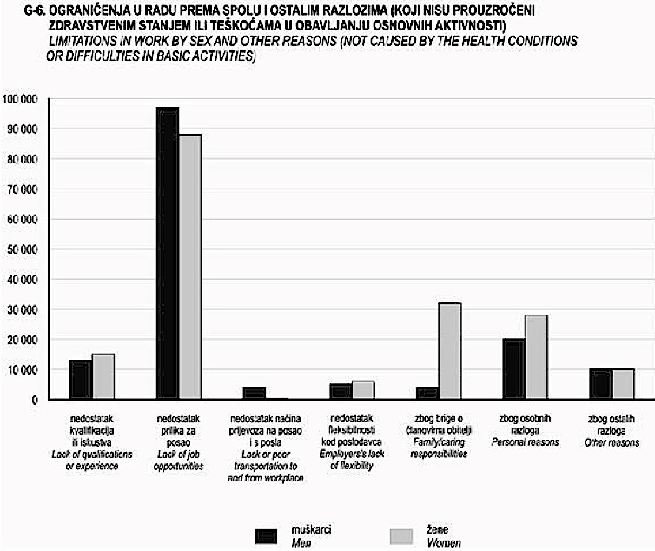

Manufacture of machinery, appliances and transport

Introduction
The manufacture of machinery and equipment is a long established tradition in the Republic of Croatia. The company Đuro Đaković was established on February 17, 1921 as the first factory manufacturing vehicles, machines and bridges, in this part of Europe. In 1956 the Faculty of Mechanical Engineering and Naval Architecture in Zagreb was opened, as was the Faculty of Metallurgy in Sisak in 1960.

Automation
Automation (ancient Greek word which means “ I manage”), robotization, industrial automation or numerical control is the use of control systems such as computers in order to control industrial machinery and processes, with the intention to replace human operators. In the field of industrialization, this is the step after mechanization. While the machinery would provide people machines that could have helped them in the physical aspects of work, automation, in addition, reduces to a large extent the need for human sensory and mental abilities.
Automation plays an increasingly important role in the global economy and everyday experience. Engineers strive to combine automated devices with mathematical and organizational tools, in order to create complex systems for the growing field of applications and human activities.
There is still much work that is not in immediate danger of automation. No device has yet been invented that could be compared with the human eye, or with the human ear, in the precision and accuracy of execution of many tasks. Even people with disabilities are able to identify and distinguish smells a lot more than any automated device. The human pattern recognition, language recognition and the ability for the reproduction of the language are far ahead of all that is currently envisioned by automation engineers...

Production
The production of machinery and transport equipment in 2009 accounted for 5.95% of Croatia’s total industrial output. 633 companies operate in this production: 586 small, 38 medium-sized and 9 large.
According to data for 2009, the index of industrial production for these industrial branches is as follows: production of machinery and appliances (and other items classified hereunder) – (C28) 71.8: production of motor vehicles, trailers and semi-trailers - (C29) 69.4; production of other vehicles (C30) 83.2. Since production in these industrial branches has good global prospects, we estimate that the following branches in Croatia have good prospects for long-term development:
- production of parts for the automobile manufacturing industry
- production of rail vehicles
- production of marine equipment
- production of machines and appliances for the manufacturing industry
- production of agricultural machinery

Long-term planning should include the encouragement of investment into higher technologies, methods of production providing greater added value and knowledge commercialisation.
The association in clusters will create a foundation for co-operation with foreign manufacturers of machines and appliances based on supply subcontracts, which would also enable penetration in foreign markets. The starting point for these initiatives are manufacturers’ associations within the Croatian Chamber of Economy, especially the Shipbuilding Industries Affiliation and the Affiliation of Manufacturers of Parts and Accessories for the Automobile Industry

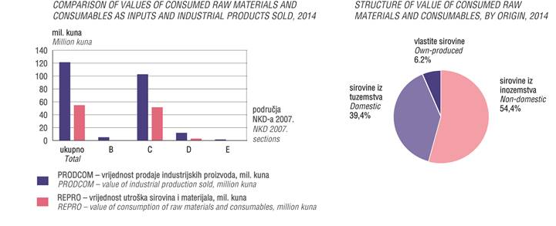

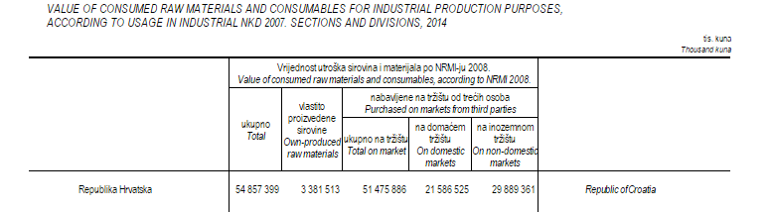
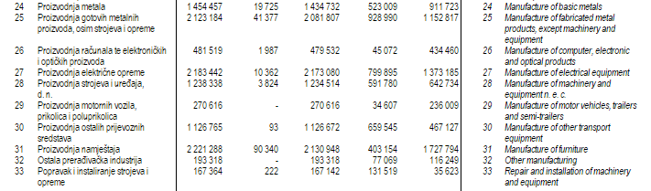

Source : http://www.dzs.hr/Hrv_Eng/publication/2015/02-01-06_01_2015.htm

Tax System

Entrepreneurial freedom and free market are the foundations of the Croatian economy. The Republic of Croatia guarantees the same legal position in the market to all entrepreneurs, both domestic and foreign. The Republic of Croatia also guarantees to foreign investors that they may take the profits and invested capital out of the country at any time. The Croatian tax system is comparable to the tax systems of EU member countries and is based on a number of direct and indirect taxes.
Croatia honours all double taxation agreements made between former Yugoslavia and other countries and has itself concluded numerous agreements on the avoidance of double taxation.
The current Croatian tax system includes the following taxes: corporate income tax; personal income tax; value-added tax; special taxes (excise duties) on certain products (oil and refined petroleum products, tobacco products, alcoholic beverages, non-alcoholic beverages, beer, coffee, automobiles and other motor vehicles, vessels and aircraft, luxury products), tax on automobile liability and comprehensive road vehicle insurance premiums; real estate transfer tax; levies on the organisation of games of chance; county, municipal and town/city taxes as part of regional and local self-governments’ revenues.

Most goods are imported and originating from the EU shall be exempted from customs duty (to enclose the statement of account up to 6000 € UR or statements approved exporter or a certificate of origin EUR.1).
Industrial robots are classified by the 8479 TBR 00 and 50 are exempt from customs duties regardless of country of origin, transporters of goods classified in the head CT and 8428 have different maximum rates of 5% (but if the EU are exempt from customs duties). Machines also have different rates.
So for each export to Croatia, it is better to engage an international forwarder, who will make you a SAD (Declaration for the calculation of benefits) and your name is submitted to Customs after inspection of goods.
For more information, go on the website about tax administration in Croatia: http://www.porezna-uprava.hr/en/

Foreign trade

Since 2000, both import and export in all economic sectors have increased. However, due to the global economic crisis, this sector has recorded a decrease, most significantly, in the period after 2009. The production of machines, appliances and motor vehicles registers a continuing deficit in trade whilst the production of other transportation registers a positive balance, largely due to shipbuilding.

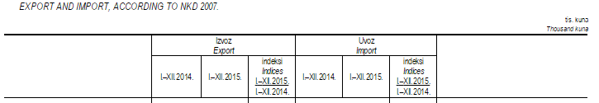
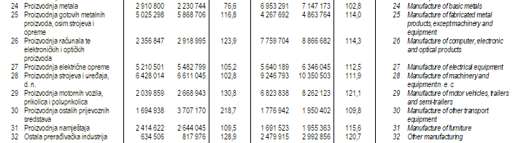

Source : http://www.dzs.hr/Hrv_Eng/publication/2016/04-02-02_01_2016.htm

Employment figures

About 38,100 employees work in the manufacture of machines, appliances and vehicles, including the boatbuilding industry. The introduction of new technologies and restructuring has reduced that number. One of the most important activities is the further training of employees and increasing productivity which will certainly raise the competitiveness of this branch. Croatian specialists in all fields who have won recognition internationally are definitely our most valuable resource and provide a solid foundation for further development, for the introduction of new manufacturing methods and technological processes, and the development of new products. It should also be pointed out that the four machine engineering and three electrical engineering faculties in Croatia (colleges) annually produce some 1,000 graduates in the fields of engineering and information technology.
Supported by the technology centres of the engineering faculties at the Universities of Zagreb, Rijeka and Split, these experts have the opportunity to develop attractive, entrepreneurially focused manufacturing programmes.

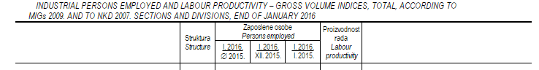

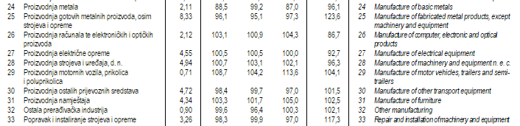

Source : http://www.dzs.hr/Hrv_Eng/publication/2016/02-01-03_01_2016.htm

Privatization

Most companies are privatised and small shareholders and private owners are the majority. The remainder are owned by government funds and banks. Larger, and predominantly state owned companies, with broad manufacturing portfolios are undergoing restructuring and strategic planning in order to be finally privatised.
Below is the list of the 10 biggest Croatian companies in machinery manufacture sector.

TŽV GREDELJ d.o.o. www.tzv-gredelj.hr gredelj@tzv-gredelj.hr
AD PLASTIK d.d. www.adplastik.hr adplastik@adplastik.hr
KONČAR – ELEKTRIČNA VOZILA d.d. www.koncar-kev.hr info@koncar-kev.hr
ALSTOM HRVATSKA d.o.o. www.astom.hr info.croatia@power.astom.com
PPC BUZET d.o.o. www.cimos.eu info-ppc@cimos.eu
ĐURO ĐAKOVIĆ SPECIJALNA VOZILA d.d. www.ddsv.hr bjerkovic@ddsv.hr
SAME-DEUTZ-FAHR ŽETELICE d.o.o. www.samedeutz-fahr.com demir.kobas@sdfgroup.com
ULJANIK STROJOGRADNJA d.d. www.strojogradnja.uljanik.hr diesel@uljanik.hr
BRODOSPLIT–TVORNICA DIZEL MOTORA d.o.o. www.brodosplit.hr strobrod@brodost.htnet.hr
3. MAJ MID d.d. www.3maj-mid.hr midfactory@3maj.hr

Fairs
Companies producing machines, appliances and vehicles, actively participate every year in many specialised fairs. The Croatian Chamber of Economy organises national joint attendance of their members on both domestic and international fairs depending on the interest of their members.
Particular fairs about automation in Zagreb are BIAM or Energetics Zagreb.
For more information about those fairs, see Zagreb fair centre: http://www.zv.hr

Industrial automation companies in Croatia

Atinel d.o.o
Manufacturer, service, distribution
Web : http://www.atinel.hr
Address : Zagrebačka, 94. 42000 Varaždin
Phone : +385 (042) 492 107
Fax : +385 (042) 492107
E-mail : atinel@atinel.hr

Duplico d.o.o
Production, service, distribution
Web : http://www.duplico.hr/
Address : Gornjostupnicka 27 b, 10255 Gornji Stupnik
Phone : +385 (01) 6589 222, +385 (01) 6589 223
Fax : +385 (01) 6589231
E-mail : duplico@duplico.hr

Elektron
Production
Web: http://www.elektron.hr
Address : Strmec 182, 49244 Stubicke Toplice
Phone : +385 (049) 282 874
Fax : +385 (049) 282869
E-mail : info@elektron.hr

Elkos d.o.o
Services, designing
Web : http://www.elkos.hr
Address : Sajmisna bb, 40329 Kotoriba
Phone : +385 (040) 682 217, +385 (040) 682 117
Fax : +385 (040) 682217
E-mail : elkos@elkos.hr

Enikon d.d
Production, services
Web : http://www.enikon.com
Address : Veslacka 2, 10000 Zagreb
Phone : +385 (01) 6190 785, +385 (01) 6190 900, +385 (01) 6064 840
Fax : +385 (01) 6190963
E-mail : enikon@enikon.t-com.hr

Ezo Automatizacija
Services, designing
Web : http://www.ezo.hr
Address : Starotrnjanska 40, 10000 Zagreb
Phone : +385 (01) 6147 261
Fax : +385 (01) 6147067
E-mail : ezo@ezo.hr

Hibos d.o.o
Services
Web : http://www.hibos.hr
Address : Mate Bozicevica 14, 44250, Petrinja
Phone : +385 (044) 813 884, +385 (044) 816 742
Fax : 044/813-886
E-mail : hibos@sk.t-com.hr

INDUSTRIJSKA ELEKTRONIKA SPIN doo

Production, services
Web : http://www.spin-split.com
Address : Karamanova 4, 21000 Split
Phone : 021 542 764
Fax : 021 542 766
E-mail : info@spin-split.hr

INDUSTROPLAN doo

Services, designing
Web : http://www.ticri.hr
Address : J. P. Kamova 19, 51000 Rijeka
Phone : +385 (0)51 218 430
Fax : +385 (0)51 218 270
E-mail : ticri@ri.htnet.hr

METALLUM doo

Production, services
Web : http://www.metallum.hr
Address : Plitvicka 45, 35000, Slavonski Brod
Phone : +385 (035) 272 442, +385 (035) 272 443
Fax : +385 (035) 272442, +385 (035) 273512
E-mail : metallum@metallum.hr

Montelektro d.o.o

Distribution, services
Web : www.montelektro.com
Address : Kudeji 53, 51215 KASTAV
Phone : +385 51 54 58 10
Fax : +385 51 54 58 11
E-mail : zagreb@montelektro.com

Mazor d.o.o
Distribution
Web : http://www.mazor-kompresori.hr/
Address : Puškarićeva 62a, 10250 Lučko-Zagreb
Phone : +385 1/6531-155
Fax : +385 1/6531-266
E-mail : zelimir@mazor-kompresori.hr

Dar d.o.o
Distribution, service
Web : http://www.dar.hr
Address : Vinogradska cesta bb 35 000 SLAVONSKI BROD
Phone : 035 / 490 – 115
Fax : 035/490 -135
E-mail : damir.grguric@dar.hr

Com-ing Trade d.o.o
Distribution
Web : http://www.com-ing.hr
Address : Domovinskog rata 56, 21000 Split, Croatia
Phone : + 385 21 361 470
Fax : + 385 21 381 345
E-mail : jmladinic@com-ing.hr

Enikon
Production, service
Web : http://www.enikon.com
Address : Veslačka 2-6, 10 000 Zagreb
Phone : +385 (801) 61 90 785
Fax : +385 (01) 61 90 963
E-mail : enikon@enikon.hr

Grafik Net
Distribution
Web : http://www.grafiknet.hr/
Address : Veslačka 2-6, 10 000 Zagreb
Phone : +385 1 6137 414
Fax : +385 1 6137 416
E-mail : grafiknet@grafiknet.hr

Iprom
Production, distribution
Web : http://www.iprom.hr
Address : Siget 21, Novaki Samoborski, 10 431 Sv. Nedelja
Phone : +385 1 3373 311
Fax : +385 1 3373 313
E-mail : iprom@iprom.hr

Nev-EL d.o.o

Distribution, services
Web : http://www.nev-el.hr
Address : Zitnjak bb, 10000 Zagreb
Phone : +385 (01) 2455 855
Fax : +385 (01) 2455856
E-mail : info@nev-el.hr

OPREMA-STROJEVI LUDBREG dd

Production, designing
Web : http://www.oprema-strojevi.com
Address : Koprivnicka 23, 42230 Ludbreg
Phone : +385 (042) 819 488, +385 (042) 306 830, +385 (042) 819 395, +385 (042) 306 856
Fax : +385 (042) 819392
E-mail: info@oprema-strojevi.com

Pelmen d.o.o

Distribution, services
Web : http://www.pelmen.hr
Address : Garicgradska 14, 10000 Zagreb
Phone : +385 (01) 3099 099, +385 (01) 3095 783, +385 (01) 3095 784
Fax : +385 (01) 3096066
E-mail : info@pelmen.hr

PHB Automatizacija

Production, services
Web : http://www.phb.hr
Address : Zitnjak bb, 10000 Zagreb
Phone : +385 (01) 2409 367, +385 (01) 2409 143
Fax : +385 (01) 2409143, +385 (01) 2409367
E-mail : info@phb.hr

Sinel d.o.o

Production, services
Web: http://www.sinel.hr
Address: Rudarska 3, 52220 Labin
Phone : +385 (052) 857 028, +385 (052) 884 000, +385 (052) 884 010
Fax : +385 (052) 884019
E-mail : sinel@sinel.hr

ST Inženjering
Services
Web : http://www.st-ing.hr
Address : Kuntica dure 34, 10362 Kasina
Phone : +385 (01) 2045 056, +385 (01) 2059 679, +385 (01) 2044 082
Fax : +385 (01) 2044082
E-mail : sting@globalnet.hr

Almas-Trade d.o.o
Production, services
Web : http://www.almas-trade.hr
Address : Varazdinska cesta 16, 10360 Sesvete
Phone : +385 (01) 2002 797, +385 (01) 2004 133, +385 (01) 2004 134
Fax : +385 (01) 2004164
E-mail : informacije@almas-trade.hr

Metal product doo
Production
Web : http://www.metal-product.hr
Address : Dacka 70, Odra, 10020
Phone : +385 (01) 6379 555, +385 (01) 6379 513, +385 (01) 6261 452
Fax : +385 (01) 6261093, +385 (01) 6379550
E-mail : info@metal-product.hr

Plastometalik
Production
Web : http://www.plastometalik.hr
Address : GLAVNA 52a, 40321, Mala Subotica
Phone : 385 (0)40 631 364
Fax : 385 (0)40 631 360
E-mail : info@plastometalik.hr

Topola
Production
Web : www.topola.hr
Address : Brace Monjaca 1, 51000, Rijeka
Phone : +385 (051) 261 237, +385 (051) 261 074
Fax : +385 (051) 261074
E-mail : topola@topola.hr

Asting d.o.o
Distribution
Web : http://www.asting.hr
Address : Trakošćanska 4/3, 10000 Zagreb
Phone : 01/ 38 36 275
Fax : 01/ 38 37 017
E-mail : asting@zg.t-com.hr

Framago d.o.o
Production, distribution
Web : http://www.framago.hr
Address : Pantovcak 117 a, 10000 Zagreb
Phone : +385 (01) 4822 160, +385 (01) 4823 923
Fax : +385 (01) 4822160, +385 (01) 4823923
E-mail : marketing@framago.hr

Interugos d.o.o
Distribution
Web : http://www.interugos.hr
Address : Pretoki 22 e, 10380, Sveti Ivan Zelina
Phone : +385 (01) 2060 593, +385 (01) 2060 001, +385 (01) 2061 602, +385 (01) 2061 603
Fax : +385 (01) 2060274, +385 (01) 2060001
E-mail : info@interugos.hr

Konding d.o.o
Distribution, services
Web : http://www.konding.hr
Address : Industrijska 19, 10360 Sesvete
Phone : +385 1 2409 440
Fax : +385 1 2409 148
E-mail : info@konding.hr

Nicro d.d.
Production
Web : http://www.nicro.hr/
Address : Marijana Cavica 9, 10000 Zagreb
Phone : +385 (01) 2450 009, +385 (01) 2458 292, +385 (01) 2455 295, +385 (01) 2455 292
Fax : +385 (01) 2450034
E-mail : info@nicro.hr

Plinotehnika d.o.o
Production
Web : http://www.plinotehnika.hr
Address : Augustina Jarica 49 a, 35000, Slavonski Brod
Phone : +385 (035) 250 730, +385 (035) 441 146, +385 (035) 445 159
Fax : +385 (035) 445159
E-mail : Online form

Tim Zip d.o.o
Distribution
Web : http://www.timzip.hr
Address : Bani 100, 10010, Buzin
Phone : +385 (01) 6608 030
Fax : +385 (01) 6608040, +385 (01) 6606022
E-mail : vladimir.bulic@timzip.hr

KONČAR - MES d.d.
Production, distribution, services
Web : http://www.koncar-mes.hr/
Address : Fallerovo setaliste 22, 10000 Zagreb
Phone : +385 (01) 3670 999, +385 (01) 3670 900, +385 (01) 3655 555
Fax : +385 (01) 3667257
E-mail : prodaja@koncar-mes.hr

Hrvatska elektroprivreda
Production, transmission, distribution
Web : http://www.hep.hr/
Address : Ulica grada Vukovara 37, 10000 Zagreb
Phone : 01/63 22 111
Fax : 01/61 70 430
E-mail : Online form

Domitran
Production
Web : http://www.domitran.hr/
Address : Krečaves 21, 10380 Sveti Ivan Zelina
Phone : +385 1 2061 506
Fax : +385 1 2062 319
E-mail : Online form

Elektro-čelik
Production, distribution, service
Web : http://www.elektro-celik.hr/
Address : Markovićeva 28, 48260 KRIŽEVCI
Phone : 048/ 681-975
Fax : 048/ 712-420
E-mail : elektro-celik@elektro-celik.hr

TEP d.d.
Production, distribution
Web : http://www.tep.hr/
Address : Labudovac 18 , 49 223 Sv.Križ Začretje
Phone : + 385 49 201 201
Fax : + 385 49 201 248
E-mail : info@tep.hr

Elka d.d. Tvornica električnih kabela
Production
Web : http://elka.hr/
Address : Koledovčina 1, 10000 Zagreb
Phone : + 385 1 24 82 600
Fax : + 385 1 24 04 898
E-mail : elka-marketing@elka.hr

Commel Zagreb
Production
Web : http://www.commel.hr/
Address : Samoborska cesta 143, 10090 Zagreb
Phone : +385 1 3436 000
Fax : +385 1 3436 010
E-mail : info@commel.hr

Trgo sim d.o.o.
Production, distribution, services
Web : http://www.trgo-sim.hr/
Address : Ive Politea 7, 10361 Sesvetski Kraljevec
Phone : +385 (0)1 20 46 532
Fax : +385 (0)1 20 46 666
E-mail : info@trgo-sim.hr

Marex - elektrostroj d.o.o. Zadar
Production, service
Web : http://marex-elektrostroj.hr/
Address : Slavka Batušića bb HR-23000 Zadar
Phone : +385 23 341016
Fax : +385 23 340157
E-mail : info@marex-elektrostroj.hr

Elektrotehnika d.o.o.
Production
Web : http://www.elektrotehnika.hr/
Address : Ulica Nikole Tesle 16 48260 Križevci
Phone : +385 (0)48 682 789
Fax : +385 (0)48 681 613
E-mail : info@elektrotehnika.hr

Energetika tim d.o.o.
Production, distribution, service
Web : http://www.energetika-tim.hr/
Address : III Pile br. 4, 10 000 Zagreb
Phone : 01 606 1136
Fax : 01 606 1136
E-mail : info@energetika-tim.com

Krovel d.o.o.
Production, services
Web : http://www.krovel.hr/
Address : Barutanski jarak 114, 10000 Zagreb
Phone : +385(0)1 23 05 788
Fax : +385(0)1 23 05 788
E-mail : damir.krovinovic@krovel.hr

Mi-Maris d.o.o.
Production, services
Web : http://mi-maris.hr/
Address : Žitna 12, 10310 Ivanić - Grad
Phone : +385 1 282 33 62
Fax : + 385 1 288 30 59
E-mail : info@mi-maris.hr

-Mato el.d d.o.o.
Production, service
Web : http://www.meld.hr/
Address : Obilaznica bb 10310 Ivanić-Gred
Phone : 01 2831 020
Fax : 01 2831 049
E-mail : info@meld.hr

Kis-info
Production, distribution, service
Web : http://www.kis-info.hr/
Address : Vrtna 17, 40 305 Nedelišće Međimurje
Phone : 091 9176 98 6
Fax : 00385 (0)40 821120
E-mail : prodaja@kis-info.hr

Tangens Proces d.o.o
Production, distribution, service
Web : http://www.tangens.hr/
Address : Perjavica 21c 10090 Zagreb
Phone : +385 1 3435 043
Fax : +385 1 3454 799
E-mail : Online form

Energoservis d.o.o
Production, distribution, services
Web : http://www.energoservis.hr/
Address : Radnička 19/II 51000 Rijeka
Phone : +385 51 437-200
Fax : +385 91 5438670
E-mail : energoservis@inet.hr

Elektroprojekt d.d.
Service, designing
Web : http://elektroprojekt.hr/
Address : Alexandera von Humboldta 4, HR-10000 Zagreb
Phone : +385 (01) 6307 777
Fax : +385 (01) 6152 685
E-mail : ured.gd@elektroprojekt.hr

Davel d.o.o.
Service
Web : http://davel.hr/
Address : Svilajska 30 E, 31000 Osijek
Phone : +385 (0)31 377 666
Fax : +385 (0)31 377 676
E-mail : Online form

Elektro Žužić
Distribution, services
Web : http://com.hok.hr/web/elektro-zuzic/
Address : Kneza Borne 10/1, 10 430 Samobor
Phone : 01 / 33 64 343
Fax : 01 / 33 64 343
E-mail : info@elektro-zuzic.hr

Abaton d.o.o.
Distribution
Web : http://abaton.com.hr/
Address : Ožegovićeva 21, 10000 Zagreb
Phone : +385 (0)1 233 90 77
Fax : +385 (0)1 233 71 83
E-mail : info@abaton.hr

Exortus d.o.o
Service, distribution
Web : http://exortus.hr/
Address : Donje Vrapče 60, 10090 Zagreb
Phone : +385 1 3733 271
Fax : +385 1 3733 271
E-mail : exortus@exortus.hr

B. Servisi
Distribution, service
Web : http://bservisi.hr/
Address : Rogićeva 33, 10020 Zagreb
Phone : +385.1.6539.777
Fax : +385.1.6539778
E-mail : info@bservisi.hr

Elektrocentar Petek
Service, distribution
Web : http://www.ecp.hr/
Address : Školska 2,10310 Ivanić-Grad
Phone : 01 5558 200
Fax : 01 2831 220
E-mail : uprava@ecp.hr

HEP-Operator prijenosnog sustava d.o.o.
Production, distribution, service
Web : http://ops.hep.hr/
Address : Kupska 4, 10000 Zagreb
Phone : +385 1 63 22 317
Fax : + 385 1 61 70 442
E-mail : Online form

HROTE d.o.o.
Distribution, service
Web : http://hrote.hr/
Address : Miramarska 23, 10000 Zagreb
Phone : +385 1 63 06 700
Fax : +385 1 63 06 777
E-mail : hrote@hrote.hr

Elektro Novak
Service, distribution
Web : http://www.elektronovak.hr/
Address : Gornji Hrašćan, Čakovečka 36, 40306 Macinec
Phone : 040/858-200
Fax : 040/858-781
E-mail : elektronovak@ck.t-com.hr

TEŽ trgovina d.o.o.
Distribution, service
Web : http://tez.hr/
Address : Folnegovićeva 10, 10000 Zagreb
Phone : +385 0(1) 61 87 138, 6187 097, 6188 624
Fax : +385 0(1) 61 87 128
E-mail:tez@zg.t-com.hr
S.C.A.N.
Distribution, service, designing
Web : http://www.scan.hr/
Address : Buzinski prilaz 38, 10010 Zagreb

Phone : +385 (1) 3707 987
Fax : +385 (1) 3707 989
E-mail : scan@scan.hr

Elektrokovina Adria
Production, distribution, service
Web : http://www.elektrokovina-adria.hr/
Address : Vukovarska 52a, 21000 Split
Phone : 021/537-900
Fax : 021/537-903
E-mail : elektrokovina-adria@st.t-com.hr

Elkakon d.o.o.
Production
Web : http://www.elkakon.hr/
Address : Žitnjak bb, P.P. 150, 10001 Zagreb
Phone : +38512452850
Fax : +38512452851
E-mail : elkakon@elkakon.hr

Exor
Production, distribution, service, designing
Web : http://ets.com.hr/
Address : Bani 73a, Buzin, 10010
Phone : +385 1 6520 025
fax :+385 1 5606 175
E-mail : info@exor.hr

TUP
Production
Web : http://www.tup-carbon-graphite.eu/
Address : Svetog Križa 3, 20000 Dubrovnik
Phone : +385 20 313820
Fax : +385 20 419127
E-mail : online form

Adriadiesel
Production
Web : http://www.adriadiesel.hr
Address : Mala Švarča 155, 47 000 Karlovac
Phone : 047/434-370
Fax : 047/434-380
E-mail : adriadiesel@adriadiesel.hr

Uljanik
Production, distribution
Web : http://www.uljanik.hr
Address : Flaciusova 1, 52100 Pula
Phone : +385 (0)52 373000
Fax : +385 (0)52 373646
E-mail : uljanik@uljanik.hr

RA Adriatic d.o.o. Rijeka
Production, service
Web : http://www.ra-adriatic.hr/
Address : Vodovodna 24, 51000 Rijeka
Phone : +385 51 374 506
Fax : +385 51 374 505
E-mail : info@ra-adriatic.hr

HEP Operator distribucijskog sustava d.o.o.
Distribution, service
Web : http://ods.hep.hr
Address : Ulica grada Vukovara 37, 10000 Zagreb
Phone : 01/63 22 111
Fax : 01/61 70 430
E-mail : Online form

Zagrebačko elektrotehničko poduzeće d.d.
Production, service, designing
Web : http://zep.hr/
Address : Draškovićeva 54, Radnička cesta 220, 10000 Zagreb
Phone : +385 (0)1 2481-777
Fax : N/A
E-mail : zep@zep.hr

Scandinavian Boiler Service d.o.o.
Service, distribution
Web : http://www.sbs.hr/
Address : Ivana Zavidića 19, 51000 Rijeka
Phone : +385-51-684-755
Fax : +385-51-684-749
E-mail : management(at)sbs.hr

Izrada i prodaja elektro-ormara, elektro-ormarića.
Production, designing
Web : http://work-ing.hr/
Address : Gospodarska 2, 42202 Varaždin
Phone : +385(0)42 658 731
Fax : N/A
E-mail : info@work-ing.hr

ENCONET International
Production
Web : http://enconet.com.hr/
Address : Miramarska 20, 10000 Zagreb
Phone : +385 1 63 12 399
Fax : +385 1 63 12 380
E-mail : enconet@enconet.hr

Fractal d.o.o
Service, designing
Web : http://fractal.hr/
Address : Kupreška 37, 21 000 Split
Phone : +385 21 600 771
Fax : +385 21 599 894
E-mail : fractal@fractal.hr

Nova energija
Distribution, services
Web : http://novaenergija.hr/
Address : Miline 132c 22 203 Rogoznica
Phone : +385 (0)22 559 002
Fax : +385 (0)22 559 008
E-mail : novaenergija@novaenergija.hr

Elektro trade
Production, distribution
Web : http://elektrotrade.hr/
Address : Zrinski trg bb, 47300 OGULIN
Phone : 047/ 525-972
Fax : 047/ 525-972
E-mail : elektrotrade@elektrotrade.hr

Hidraulika Rijeka
Production, distribution
Web : http://www.mikronrijeka.com
Address : Trampov breg 43/b 51216 Viškovo,Rijeka
Phone : 051/ 681 176
Fax : 051/ 681 325
E-mail : info@mikronrijeka.com

Tesla kabeli d.o.o.

Distribution
Web : http://teslacables.hr/
Address : Industrijska 20, 10431 Sveta Nedelja, Hrvatska
Phone : +385 (0)1 2362-900
Fax : +385 (0)1 2362-901
E-mail : info@teslacables.com

http://ec.europa.eu/economy_finance/eu/countries/croatia_en.htm
http://www.europeanbestdestinations.com/

