Alternative energy in Ukraine: market overview
Ukraine has an area of 603,628 km2 (233,062 sq mi), making it the largest country entirely within Europe. Ukraine borders Russia to the east and northeast, Belarus to the northwest, Poland, Slovakia and Hungary to the west, Romania and Moldova to the southwest, and the Black Sea and Sea of Azov to the south and southeast, respectively.
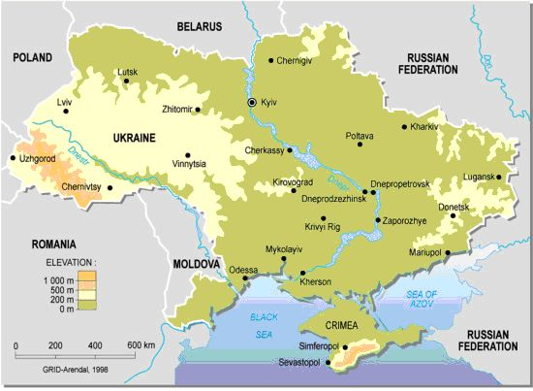

In 2014, Ukraine was ranked number 19 on the Emerging Market Energy Security Growth Prosperity Index, published by the think tank Bisignis Institute, which ranks emerging market countries using government corruption, GDP growth and oil reserve information.
Ukraine has been a net energy exporting country, for example in 2011, 3.3% of electricity produced were exported, but also one of Europe's largest energy consumers. As of 2011, 47.6% of total electricity generation was from nuclear power. The largest nuclear power plant in Europe, the Zaporizhzhia Nuclear Power Plant, is located in Ukraine. Most of the nuclear fuel has been coming from Russia. In 2008 Westinghouse Electric Company won a five-year contract selling nuclear fuel to three Ukrainian reactors starting in 2011. Following Euromaidan then President Viktor Yanukovich introduced a ban on Rosatom nuclear fuel shipments to Europe via Ukraine, which was in effect from 28 January until 6 March 2014. After the Russian annexation of Crimea in April 2014, the National Nuclear Energy Generating Company of Ukraine Energoatom and Westinghouse extended the contract for fuel deliveries through 2020.
Coal- and gas-fired thermal power stations and hydroelectricity are the second and third largest kinds of power generation in the country.

Energy markets in Ukraine have inherited the production capacities and technologies from Soviet times, but since Ukraine’s independence they underwent a number of substantial changes in organisational and ownership structure.
Ukraine depends on three types of generation facilities i.e. thermal power plants (steam turbine and diesel types), hydroelectric plants (hydroelectric proper and hydroelectric accumulating plants) and nuclear power plants. The role of wind and helium power plants is minor; however it is increasing gradually. Capacity distribution among different types of power plants is shown in Diagram 1.
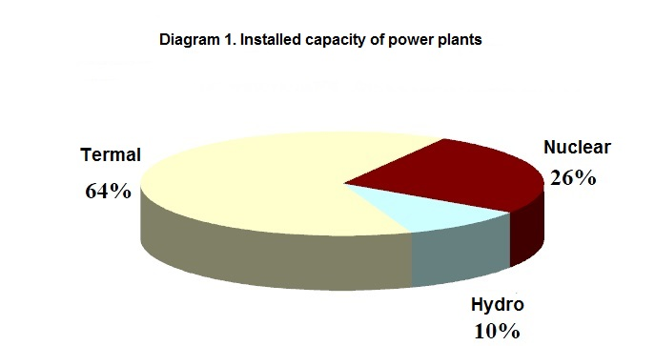
Source: UA Energy

According to the information, provided by the Ministry of Energy and Coal Industry of Ukraine, in 2013 the Ukrainian industry of alternative energy produced 1.247 billion kilowatt-hours, which is approximately twice as much as the amount produced in 2012 (638,6 million kilowatt-hours). Furthermore, in 2013 the electrical energy produced out of renewable energy sources accounted for 0.64% of the total amount of electrical energy produced in Ukraine (0.32% of the total amount in 2012). There were new renewable energy facilities with production capacity of 539 megawatt placed in operation in 2013. The most significant growth showed wind power industry, solar energy industry and facilities that rework biomass.

Figure 1
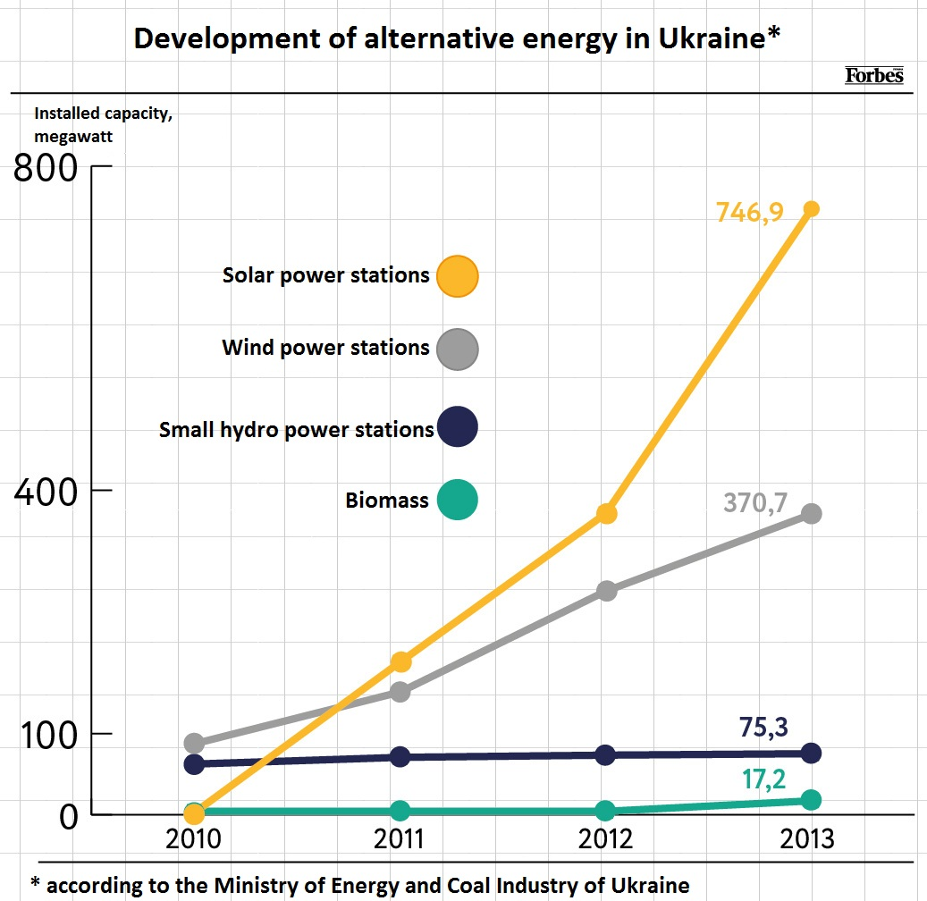
According to the Energy Strategy of Ukraine 2030, it is planned that the share of alternative energy will amount to 11% of the total amount of energy produced in Ukraine in 2020. These 11% account for 12000 megawatt (6800 megawatt will be delivered by hydroelectric power stations and pumped-storage hydroelectric power stations, 5200 megawatt will be delivered by small hydro power stations, wind power stations, solar power stations, biomass and biogas).

Table 1
Renewable energy plants built in Ukraine in 2013*
Region (oblast) | Type of energy | Company-operator | Location (Name) | Output (MW)
Kyivska | Biogas | Biogasenergo | Ivankiv village | 6
Kyivska | Wind power | VodEnergoRemNaladka | Boryspil | 1,2
Vinnytska | Solar power | Martifer Solar Holding (Portugal) for Rengy Development (Kyiv) | Tomashpolskyi rayon | 4,5
Vinnytska | Solar power | Martifer Solar Holding (Portugal) for Rengy Development (Kyiv) | Bershadskyi rayon | 7
Lvivska | Solar power | Eco-Optima | Sambir | 3,1
Lvivska | Solar power | Eco-Optima | Sambir | 5
Ivano-Frankivska | Solar power | Eco-Optima | Bogorodchansk | 2,8
Ivano-Frankivska | Solar power | Gelios-Energy | Radchevsk | 3,99
Zakarpatska | Solar power | Sonyachna Energiya Plus | Irlyava village | 10,09
Odeska | Solar power | Activ Solar | Bolgrad | 34,14
Odeska | Solar power | Activ Solar | (Lymanska SPS) | 43,44
Odeska | Solar power | Activ Solar | (Priozerna SPS) | 54,8
Mykolaivska | Solar power | Activ Solar | Voznesensk | 29,3
Dnipropetrovska | Solar power | Solar Park Podgornoye | (2 solar plants) | 1,65
Khersonska | Solar power | Solarenergo | Lazurno village | 9,8
Khersonska | Wind power | Vindkraft Ukraina | (Novorossiyska WPS) | 6
Zaporizka | Wind power | Wind Power DTEK | (Botiyivska WPS) | 27
Zaporizka | Solar power | Tokmak Solar Energy |  | 2,5
Donetska | Wind power | Wind parks of Ukraine | Bezimenne village | 5
Luganska | Wind power | Wind parks of Ukraine | Verhneshyverevka village | 25
Luganska | Wind power | Wind parks of Ukraine | (Ostaninska WPS) | 25
Autonomous Republic  of Crimea ** | Wind power | Sivashenergoprom | (Sivashska WPS) | 0,6
Autonomous Republic  of Crimea ** | Wind power | Ministry of Defence of Ukraine | (Tarhankutska WPS) | 4
Autonomous Republic  of Crimea ** | Wind power | VodEnergoRemNaladka | (Sakska WPS) | 0,6
Autonomous Republic  of Crimea ** | Solar power | Activ Solar | Mykolaivka | 69,7

* According to the IBCentre, Ukrainian wind power association
** Territories occupied by Russian military forces

As of September 1, 2012, there were 26 solar power stations in Ukraine (15 in Crimea, 2 in Odeska oblast, 5 in Vinnytska oblast, and Zakarpatska, Dnipropetrovska, Cherkaska and Luganska oblast have 1 station each); 11 wind power stations (5 in Crimea, 2 in Khersonska oblast, 2 in Donetska oblast, and Lvivska and Mykolaivska oblast have 1 station each); 10 biomass and biogas plants (4 in Kyivska oblast, 2 in Donetska oblast, and Lvivska, Ternopilska, Kirovogradska, Cherkaska have 1 station each); and 77 small hydro electric power stations across different regions (oblast) of Ukraine.

Figure 2
Map of Ukraine
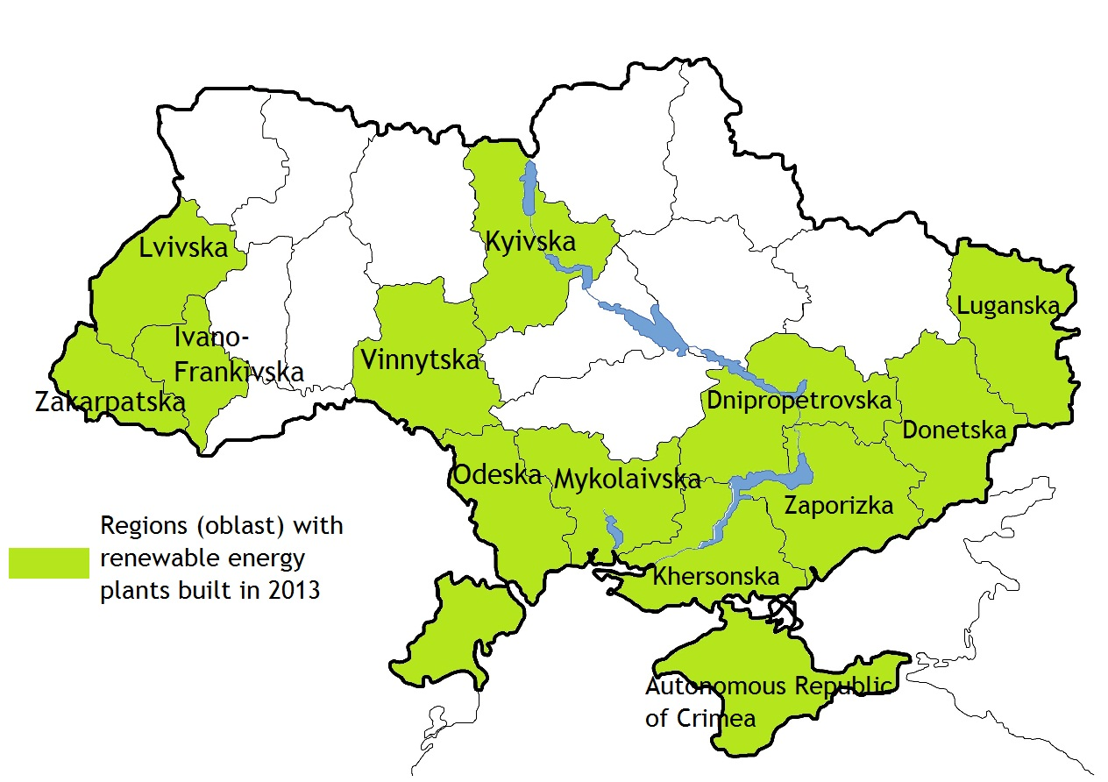
Figure 3

*According to the State Statistic Service of Ukraine

Figure 4

* Including Crimea

Figure 5

Figure 6

It should be noted that during the period of 2012-2013 Ukraine reached the list of top countries with the highest rate of development of renewable energy sources. However, investments in the projects that deal with renewable energy sources may become less appealing due to the economic instability, invasion and occupation of Crimea and changes in politics towards “green” undertakings.
According to the experts, there are different legislative proposals under discussion that deal with changes to current “green” tariffs and amounts of the “local component” (the amount of Ukrainian raw products, components, services etc, that companies must use in the production process). These changes to the tariffs and amounts of the “local components” will affect both active and planned solar power stations.
As of the April 1,, 2014, the national commission for regulation of energy sector has approved the tariff of €0.45 per 1 kWh for the majority of solar power stations, the tariff of €0.111 per 1 kWh for wind generators, and the tariff of €0.021 per 1 kWh for the National Nuclear Energy Generating Company of Ukraine (Energoatom). The government proposed to reduce the tariff for solar power stations and charge them 1.8 times less. One should not forget the fact that the vast majority of powerful heliostations are under control of brothers Serhiy and Andriy Klyuyev (Active Solar Company) that were lobbying their business in the Cabinet of Ministers of Ukraine under Prime Minister Mykola Azarov and runaway-President Viktor Yanukovych.
Another point is that large solar power stations are located in the temporary occupied Crimea, and Ukraine has abandoned paying for the electricity they produce.
According to the current legislation, starting from July 1, the amount of obligatory “local component” will be raised from 30% up to 50% for the solar power stations, and this increase may block the industry since lots of things are need to be imported. Market participants offer to introduce two changes to the Law of Ukraine on the power industry: the “local component” should be cancelled and the “green” tariff for solar power stations should be reduced down to €0.22-0.25 per kWh.
Experts believe that biomass energy may allow Ukraine to partly replace the natural gas with renewable source of energy. During upcoming years Ukraine can replace more than 3.5 billion of cubic meters of gas per year (which accounts for 7% of consumed gas and 10% of imported gas in 2013), and there is a potential to replace 18% of the total amount of the energy consumption.
However, the biomass is mostly consumed in the process of production of heat, and the key consumer of heat in Ukraine is public utility sector. Experts claim that in the current situation there are two ways in which the government can replace the natural gas with biomass in the public utility sector. The first one implies waiting until the tariff for heat for the society reaches the market value so that the heat produced out of biomass becomes profitable. Under the current speed of tariff increase this will happen later than in 2 years. The second way implies starting of the mechanism of redistribution of subventions for heat produced from biomass (there are no mechanisms designed now), so that these projects will become profitable now. Currently the subsidy for the heat produced out of gas amounts to €36.251 per 1 Gcal, VAT excluding. In case the state introduces subsidies for the heat produced out of biomass, then the subsidy will account for €20.881 per 1 Gcal, VAT excluding. Moreover, experts claim that there are no “green” tariffs for the heat produced out of biomass, so the prospective investors are not required to obtain them.
Renewable energy sector in Crimea.
It is important to mention that temporary annexation of Crimea has a dramatic impact on the renewable energy sector in Ukraine, since about half of the total installed capacity of Ukrainian renewable energy plants are located in the occupied Crimea. The renewable energy plants produce 5.6% of consumed energy in Crimea, while across entire Ukraine these plants produce less than 1 % of consumed energy. Crimea is considered to be the most perspective area for renewable energy sector due to the steady winds and more than 250 sunny days per year. However, Crimea still faces energy deficit. The joint installed capacity of renewable energy plants in Crimea amounts to 407 MW, mainly operated by the Activ Solar company of Klyuyev brothers. About 227 MW from the stated above amount were already in operation and were connected to the joint power system of Ukraine, 69 MW on the solar power station “Nikolaevka” were in the checkout process before connection to the joint power system of Ukraine, and about 110 MW on the solar power station “Vladislavovka” were waiting for the decision concerning connection to the joint power system. As for the wind power stations, there were about 100 Mw connected to the joint power system of Ukraine, and about 125 Mw were either under construction or in the process of connection to the joint power system.

Table 2
Largest wind power stations situated in Crimean Peninsula
Name | Installed capacity, MW (in 2013) | Company
Tuzlovska | 12,5 | LLC "Management Company  "Wind Parks of Ukraine""
Prisnovodnenska | 7,4 | Public enterprise "VodEnergoRemNaladka"
Ostaninska | 25 | LLC "Management Company  "Wind Parks of Ukraine""
Shidno-Krymska | 2,8 | Public enterprise "Krymski generuyuchi systemy"
Prysivashska | 0 (25 is planned)* | LLC "Management Company  "Wind Parks of Ukraine""
Donuzlavska (Sudak area) | 3,8 | Public enterprise "Donuzlavska wind power station"
Donuzlavska (Donuzlav area) | 6,7 | Public enterprise "Donuzlavska wind power station"
Donuzlavska (Chornomorskyi area) | 1,2 | Public enterprise "Donuzlavska wind power station"
Sakska (Vorobyevskyi area) | 2,4 | Public enterprise "VodEnergoRemNaladka"
Sakska (Mirnovskyi area) | 18,5 | Public enterprise "VodEnergoRemNaladka"
Tarhankutska | 20 | Public enterprise "28 Upravleniye nachalnika rabot"
Zahidno-Krymska | 125** | LLC "Zahidno-Krymska wind power station"
* is under construction
**is in the process of connection to the joint power system

Table 3
Largest solar power stations situated in Crimean Peninsula
Name | Installed capacity, MW (in 2013) | Company
Solar power plant "Vladislavovka" | 25,0 (110,0 is planned) | Active Solar GmbH
Solar power plant 'Rodnikovoe" | 7,5 | Active Solar GmbH
Solar power plant "Perovo" | 106 | Active Solar GmbH
Solar power plant "Nikolaevka" | 69,7* | Active Solar GmbH
Solar power plant "Mityaevo" | 31,6 | Active Solar GmbH
Solar power plant "Ohotnikovo" | 82,7 | Active Solar GmbH
Solar power plant "Kovylnoe" | 12 | Ekotechnik Czech, s.r.o.
Solar power plant in Sevastopol | 2,2 | LLC "VS Energy International Ukraine"
*is in the process of connection to the joint power system

It is important to mention that as of May 16, 2014, all the solar power stations in Crimea, operated by Activ Solar, are halted. The press service of Activ Solar stated that the halt is caused by the regulatory uncertainty concerning renewable energy sector, the buyers of electric power are not specified and tariffs are not designed yet. Moreover, the new projects of the company are suspended. According to the Russian magazine “Kommersant”, wind power stations located in Crimea are halted as well.
Useful links.

Name of the company | Address | Tel., fax, e-mail
АSSOCIATION OF ALTERNATIVE FUEL AND ENERGY MARKET PARTICIPANTS (APEU) | 121, Saksaganskogo Str., office 197, Kyiv, Ukraine | Tel.: +380 44 362 04 90  Fax: +380 44 596 97 10  info@apeu.info  http://www.apeu.info/en/

Amounts are calculated based on the exchange rates stated by the National Bank of Ukraine on April 14, 2014.

