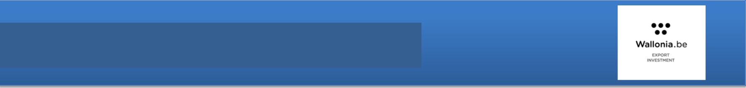
FICHE SECTORIELLE

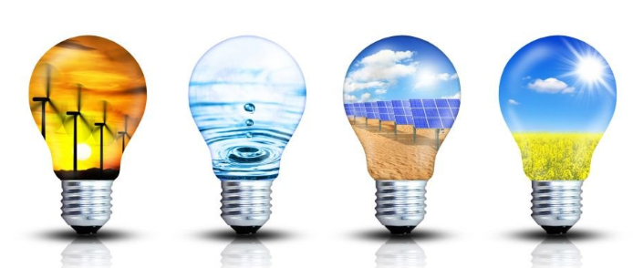SERBIA - SUSTAINABLE ENERGY

Serbian Energy Sector Overview

Serbia has committed itself to using 27% of gross final energy consumption from renewable sources by 2020. This target is based on an agreement with the Energy Community. However, the current percentage is only around 22%, so Serbia still has a long way to go. Serbia has significant potential in the utilization of renewable energy sources, as it is only using one third of its potential for renewables. Majority of 22% of gross final energy consumption from renewable sources comes from the large hydro power plants that were built in 1950's and 1960's. Poor energy efficiency and high carbon intensity due to still heavy reliance on fossil fuels are among the main challenges in the energy sector.

Strategic Priorities of energy Sector Development in Serbia by 2030

Provision of energy security, energy market development and overall transition towards sustainable energy sector are imposed as key priorities of energy sector development in the Republic of Serbia, i.e. principles based on which the energy sector policy by 2030 should be developed. Creation and development of energy market is a key assumption for economically sustainable development of the energy of the Republic of Serbia. That means establishment of energy market based on the principles of competition, publicity and free initiative of energy entities. This should provide customers free choice related to energy and energy products supply, by which their price should depend more on offer and demand. However, principled and transparent manner of gradual, but certain establishment of appropriate price parity, that is based on including full amount of environmental charges and costs in the energy price shall remain the permanent task of energy policy. This internal regulatory framework, with regional market liberalization, would provide regional integration of national market.

Renewable energy and opportunities

Hydropower, particularly small hydro, and biomass (both agricultural and wood-based) could be used significantly more in energy production. As Serbia's EU accession process progresses, it is likely that Serbia will have to increasingly take energy efficiency and renewable sources of energy into account. Focus in the energy field will be on modernization of District Heating (DH) plants and power plants, as well as introduction of renewable energy sources, especially wood biomass. Woody and agricultural biomass potential in Serbia amounts to approximately 3.4 Mtoe (million tons of oil equivalents) per year. Out of this, 2.3 Mtoe per year is unused potential.

The most of the Serbia’s theoretical RES (renewable energy sources) potential is in biomass (49 %). Biomass potential is relevant for the modernization of DH systems in Serbia and realizing a fuel switch. The rest of the potential is in large HPPs (27 %), solar energy (13 %), wind energy (4%), geothermal energy (4 %) and small HPPs (3 %).

FICHE SECTORIELLE

According to the Draft action plan for RES, Serbia should build some 1,100 MW in RES power plants until 2020. Overall investments in above mentioned projects are estimated at 2 billion euros. The Action plan envisages the increase of the share of RES power plants in overall electricity production from 29 %, in this moment, up to 37 % until 2020 (including large hydro). In the same time, Serbia wants to increase the share of green energy in overall energy consumption from 21.2 % up to 27 % until 2020. In line with the target of 27% of production from renewable energy sources in gross final consumption until 2020, around 3,500 GWh should be provided from power plants fuelled by renewable energy sources.

The Preliminary National Plan of the Republic of Serbia for Emission Reduction envisaged the operation of some of the oldest thermal units by 2026 where, due to old-fashioned technology, the implementation of measures for the reduction of emission of sulphur and nitrogen oxides was not planned. These units will gradually stop operating and their production will be replaced by the above mentioned new capacities. Long-term energy stability also requires prudential adjustment of the energy sector of Serbia to global and EU requirements related to the protection of the Planet, in line with the results of the UN Climate Change Conference.

In the future, this may have a significant impact on the costs of electricity production in thermal power plants and to its further development. In order to achieve the realization of the adopted national goals, it is envisaged to install larger capacities for the production of electricity using wind, biomass and sun.
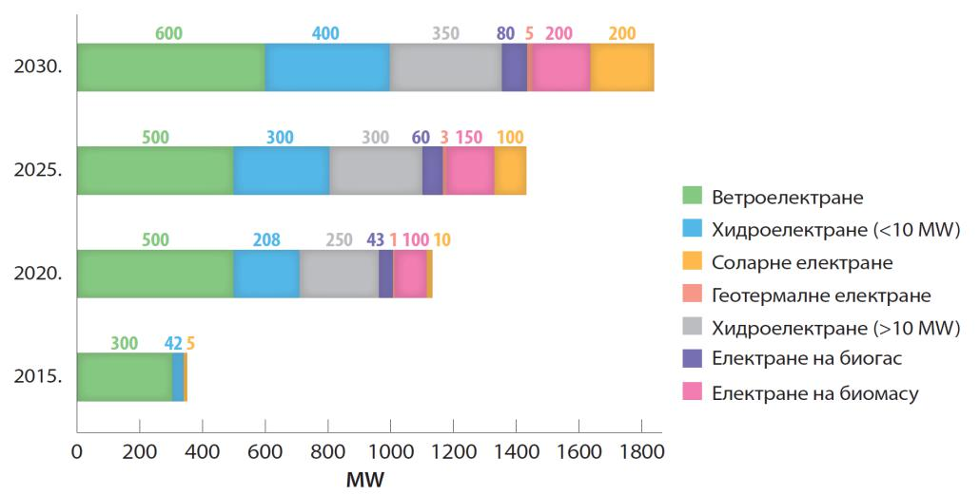

Projection of capacity building for the production of electricity by using of renewable energy in Serbia: 2015-2030

Wind power plants; Hydroelectric power plants (<10MW); Solar power plants; Geothermal power plants Hydroelectric power plants (>10MW) ; Biogas power plants; Biomass power plants

General conclusion regarding renewable energy sources in the Republic of Serbia is that they have not been sufficiently explored and one of the priority activities will be the implementation of Action Plan for RES by 2020. Potentials of renewable energy sources of the Republic of Serbia are significant and estimated at 5.65 million toe per annum. From this, more than 60% is biomass potential, whose usage is currently estimated at around 30% of available potentials. Available technical hydro potential has a share of 30% of total RES potential.

Solar energy

According to the solar potential, Serbia is among the most favourable locations in Europe. In Serbia, an increasing number of solar systems with flat plate solar collectors to heat water have been installed on the public and private facilities. Up to now two larger PV solar power plants of 2 MW (in Merdare and Velesnica),
FICHE SECTORIELLE

more than 200 independent PV solar power plants of 1 – 60 kWp and several small rooftop PV solar power plants connected to the grid have been installed.

Wind energy

There are also several locations suitable for the construction and operation of the wind generators in Serbia. However, despite significant wind energy potential and interests of the domestic and foreign investors for the construction of wind generators, Serbia has built one wind park in Kula, with higher power of 9.9 MW and wind park in Alibunar 8MW , while the wind energy potential in Serbia ranges from 8-15 GW.

Biomass

Total biomass energy potential in the Republic of Serbia comprises remains or waste in forestry and wood industry, in farming, livestock raising etc. Forest biomass accounts for 39.8% of the total energy potential of biomass in Serbia. There are good conditions for the production of briquettes and pellets in Serbia and for their use for private facilities heating. The energy potential of biomass in livestock that is suitable for the production of biogas in Serbia is estimated at 42 000 Mtoe. Thus, biogas obtained from manure is used in several places in Vojvodina. Production and consumption of solid biomass, includes, not only the production and consumption of firewood, but also the production of pellets and briquettes, for energy purposes (heating). Biomass production in 2016 in the Republic of Serbia was 1.103 Mtoe, of which the largest part of 0.897 Mtoe was consumed in households. Currently, Serbia is importing significant quantities of energy, even though it has the potential to become an energy independent country. From the long term perspective, it may be expected that the import of energy will be reduced to a minimum and that Serbia will become a significant exporter of energy. Since biomass is a major source of renewable energy, it may be one of the main sources of energy production.

Table 1: Detailed structure of the biomass potential

 |  |  | Available |  | Unused available |  | Total available
 |  |  | technical |  | Unused available |  | technical
 | Biomass |  | technical |  | technical |  | technical
 | Biomass |  | potential in use |  | technical |  | potential
 |  |  | potential in use |  | potential (Mtoe) |  | potential
 |  |  | (Mtoe) |  | potential (Mtoe) |  | (Mtoe)
 | Agricultural biomass |  | 0,033 |  | 1,637 |  | 1,67
 | Residues of agricultural crops |  | 0,033 |  | 0,99 |  | 1,023
 | Residues in fruit growing, viticulture and fruit processing |  | - |  | 0,605 |  | 0,605
 | Liquid manure |  | - |  | 0,042 |  | 0,042
 | Wood (forest) biomass |  | 1,021 |  | 0,509 |  | 1,53
 | Energy crops |  | - |  | - |  | not available
 | Biodegradable waste |  | 0 |  | 0,248 |  | 0,248
 | Biodegradable public utilities waste |  | 0 |  | 0,205 |  | 0,205
 | Biodegradable waste (excluding public utilities) |  | 0 |  | 0,043 |  | 0,043
 | Total: |  | 1,054 |  | 2,394 |  | 3,448

Source: Strategy for Energy Development of the Republic of Serbia until 2025 with projections to 2030 Potential of a primary biodegradable waste is estimated at 205 thousand toe, public utilities waste and waste edible oils and animal waste is estimated at a total amount of 0.043 million toe per year. A potential of biodegradable public utilities waste is still not exploited.
FICHE SECTORIELLE

Bioethanol can be generated from grain, potatoes, sorghum and Jerusalem artichoke, for the growing of which there are about 100,000 hectares of marginal land in Serbia. Biodiesel can be generated from oil crops: sunflower, soybean and rapeseed, the cultivation of which can be carried out on 350,000 hectares, which would enable the annual generation of about 220,000 t of biodiesel. Also, it is possible to collect about 10,000 tons of edible oils waste suitable for biodiesel generation.

In the Southern, Southwestern and Southeastern, and even Eastern areas of the Republic of Serbia, whole towns and villages use firewood as a main energy source for heating. It is used predominantly in a simple and energy-inefficient way of using the combustion devices older than 20-30 years. Also, residues and waste generated during the primary and/or industrial wood processing are, at the same time, used to generate heat for their own use, without their further preparation/processing into high-value fuels.

Current capacities for pellet production in the Republic of Serbia amounted to around 150,000 tons/year. Until a few years ago, almost 90% of current production was exported. Today, such a percentage is slightly lower, i.e. 70-65%.

Table 2: Exports of wood biomass

 | Export |  |  | 2012 |  |  | 2013 |  | 2014
 | Pellet (kg) |  |  | 52.969.859 |  |  | 103.039.206 |  | 104.468.028
 | Pellet (USD) |  |  | 9.999.032 |  |  | 21.748.093 |  | 21.557.936
 | Firewood (m³) |  |  | 45.697,88 |  |  | 39.099,89 |  | 32.820,47
 | Firewood (USD) |  |  | 2.284.894,00 |  |  | 2.150.494,00 |  | 2.166.151
 | Briquette (kg) |  |  | 96.510 |  |  | 11.595.123 |  | 14.759.538
 | Briquette (USD) |  |  | 12.614 |  |  | 1.588.055 |  | 1.944.652
 | Source: SCoC
 | Table 3: Imports of wood biomass
 | Import |  |  | 2012 |  |  | 2013 |  | 2014
 | Pellet (kg) |  |  | 4.091.476 |  |  | 2.881.985 |  | 2.538.947
 | Pellet (USD) |  |  | 711.527 |  |  | 512.051 |  | 416.559
 | Source: SCoC

The high price of basic energy sources, increasingly stringent requirements of national regulations in the environmental protection area, the popularization of renewable energy sources from year to year, increasing demand on the domestic market made it possible to modernize and improve production of devices for combustion of solid biomass. With the arrival of renowned manufacturers of equipment on biomass and installing of production lines, it came to life both the market supply and the demand of furnaces and boilers on biomass. In 2014, Serbia has become a regional leader in the manufacture of biomass boilers.

Hydropower

Hydropower provides about 25% of the total electricity produced in the country. The installed capacity of hydropower plants in Serbia is 2831 MW, which represents 34% of the total installed electric power
FICHE SECTORIELLE

resources for electricity generation. 31 small hydropower plants with a total output of 34.654 MW and annual electricity production of 150 GWh are in operation in Serbia today. Electricity production from large and small watercourses was included in the balance of the total electricity production in the Republic of Serbia and was 11,520 GWh or 0.991 Mtoe. This means that in 2016 the hydropower plants produced 29% of the total gross electricity generation.

Geotermal

By its geothermal resources, Serbia belongs to the richer countries. Currently, only 9% of the available geothermal energy potential is used. The use of geothermal energy for heating and other energy purposes is still at an early stage and very modest .Geothermal energy production is followed by the Statistical Office of the Republic of Serbia within their statistical surveys and in 2016 this production was 0.0051 Mtoe which is less than 1% of the total domestic production of primary energy. This data did not cover use of geothermal energy through the use of heat pumps.

Energy Efficency

Serbia has a very significant energy savings potential. It is estimated that the building sector consumes about 34% of total final energy, of which the residential sector used about 70%, commercial buildings 18% and public buildings 12%. The energy intensity of Serbia is four times higher than that of OECD countries. Poor energy efficiency and high carbon intensity due to heavy reliance on fossil fuels are two of the main challenges in the Serbian energy sector. The government needs to make important strategic decisions to set the course for energy efficiency legislation, its implementation and market expectations.

Since 2015, Serbia made good progress towards transposing the Energy Efficiency acquis. However, efforts must continue, in particular on full harmonisation with legislation. Given that energy is the most scattered in industrial plants and in the building sector, this means that the greatest effect can be achieved in implementing the necessary measures for energy efficiency. Bearing in mind that Serbia has the obligation to achieve the final energy savings of 9 percent by 2020 compared to the 2008 consumption, the National Energy Efficiency Action Plan has been established and a project to improve energy efficiency in public buildings is at the moment being implemented in Serbia, and is scheduled to last until 2018.

Auteur : AWEX – Belgrade
Fiche rédigée par Mme Marijana Milosevic
Janvier 2018
belgrade@brusselsinvestexport.com

